

PROJECT REPORT

on

Management Information System

HINDUSTAN AERONAUTICS LIMITED

ENGINE DIVISION

KORAPUT, ODISHA



**Submitted by:**

Radhika Parameswari

Roll NO: 33704

REGD NO:

DIPLOMA

COMPUTER SCIENCE & ENGINEERING



**CERTIFICATE**

This is to certify that Miss. Radhika Parameswari VT NO: ………(D.E) of Apperentice Trainee , Computer Engineering has submitted her report on “ Management Information System ” successfully under my guidance in the Vocational Training during the period of 30-03-2021 to 07-05-2021 at “Hindustan Aeronautics Limited (HAL), Engine Division,Koraput”.Her conduct was satisfactory . I wish her all success in life.



**ACKNOWLEDGEMENT**

I would like to express my sincere thanks to the concerned authorities of HAL, Engine Division, Koraput for giving me the opportunity to undergo Vocational Training in their esteemed organisation .I would like to express my gratitude to all those who have helped and guided me for this project/internship.

The guidance of our department and respected shop authorities have helped me understand the co-ordination between people and machines. I have come across various new terms after visiting different shops. I have understood the value and perfection of these engine parts. The working of different shops was explained very well. It was interesting to learn about how much importance even small parts like Surge Warning Switch holds in an aircraft; how CNC is used for operating machines; how casting process works and so many other processes. It was a really valuable learning experience overall.

# **Contents:**

* *About HAL*
* *History*
* *Plant Visit*
* *ER Diagram*
* *Tool Requirements*
* *Code*
* *Output*
* *Conclusion*

# **About HAL:**

Hindustan Aeronautics Limited(HAL) is an Indian state owned aerospace and defence company headquartered in Bangalore,India.It is governed under the management of the Indian Ministry of Defence.

The government owned corporation is primarily involved in the operations of the aerospace and is currently involved in the design, fabrication and assembly of aircraft, jet engines, helicopters, and their spare parts. The HAL HF-24 Marut Fighter bomber was the first fighter aircraft made in India.

Engine Division, Koraput was established in the year 2004 to manufacture AL31FP Engines for fitment in Su-30MKI Aircraft under Licence from Russia. In 2007-08 facilities were established for overhauling of AL31FP Engines under licence from Russia. Over last five decades, Division has manufactured more than 350 engines and overhauled more than 300 Aero Engines with an aim to ensure maximum aircrafts flying.



# **History:**

The history and growth of Hindustan Aeronautics Limited is synonymous with the growth of Aeronautical industry in India for more than 79 years. The Company which had its origin as Hindustan Aircraft Limited was incorporated on 23 Dec 1940 at Bangalore by Shri Walchand Hirachand, a farsighted visionary, in association with the then Government of Mysore, with the aim of manufacturing aircraft in India. In March 1941, the Government of India became one of the shareholders in the Company and subsequently took over its management in 1942. In collaboration with the Inter Continental Aircraft Company of USA, the Company commenced its business of manufacturing of Harlow Trainer, Curtiss Hawk Fighter and Vultee Bomber Aircraft.  
  
In January 1951, Hindustan Aircraft Limited was placed under the administrative control of Ministry of Defence, Government of India. The Company had built aircraft and engines of foreign design under licence, such as Prentice, Vampire & Gnat. It also undertook the design and development of aircraft indigenously. In August 1951, the HT-2 Trainer aircraft, designed and produced by the company under the able leadership of   Dr. V.M.Ghatge flew for the first time. Over 150 Trainers were manufactured and supplied to the Indian Air Force and other customers. With the gradual building up of its design capability, the company successfully designed and developed four other aircraft i.e. two seater 'Pushpak' suitable for flying clubs,  'Krishak' for Air Observatory Post (AOP) role, HF-24 Jet Fighter '(Marut)' and the HJT-16 Basic Jet Trainer '(Kiran)'.  
  
Meanwhile, in August 1963, Aeronautics India Limited (AIL) was incorporated as a Company wholly owned by the Government of India, to undertake manufacture of   MiG-21 aircraft under licence. Factories were setup at Nasik (Maharashtra) & Koraput (Odisha). In June 1964, the Aircraft Manufacturing Depot which was set up in 1960 at Kanpur as an Air Force unit to produce the Airframe for the HS-748 transport aircraft was transferred to AIL. Soon thereafter, the Government decided to amalgamate Hindustan Aircraft Limited with AIL so as to conserve resources in the field of aviation where the technical talent in the country was limited and to enable the activities of all the aircraft manufacturing units to be planned and co-ordinated in a most efficient and economical manner.  
  
Amalgamation of the two companies i.e. Hindustan Aircraft Limited and Aeronautics India Limited was brought about on 1st Oct 1964 by an Amalgamation Order issued by the Government of India and the Company after the amalgamation was named as "Hindustan Aeronautics Limited (HAL)" with its principal business being design, development, manufacture, repair and overhaul of aircraft, helicopters, engines and related systems like avionics, instruments and accessories.

In 1970, a separate division was set up exclusively for manufacture of 'Chetak' and 'Cheetah' Helicopters in Bangalore under licence from M/s SNIAS, France. A new division was also established to manufacture aircraft instruments and accessories at Lucknow. Licence agreements were entered into with M/s Dunlop of U.K. for Wheels and Brakes, Dowty for under carriages and Hydraulic equipment and Normal Air Garret for cabin air pressurisation and air-conditioning equipment, Smiths of UK, SFENA and SFIM of France for panel instruments and Gyros, Martin Baker of UK for ejection seats and Lucas for engine fuel systems; for fitment on Marut, Kiran, Ajeet, Chetak, Cheetah and Jaguar. Similar type of arrangement was agreed with USSR authorities for manufacture of accessories for MiG-21 series of aircraft.  
  
Design and Development of Basant agricultural aircraft was undertaken between 1970 and 1974 and design and development of Ajeet, an improved version of Gnat, was undertaken between 1972 and 1980. In 1976, projects were sanctioned for design & development of the HPT-32 elementary piston engine trainer, Kiran MK II (an improved version of Kiran MK I / IA) and Ajeet Trainer as well as for Advanced Light Helicopter.  
  
In 1971, Avionics Design Bureau at Hyderabad was formed for the development and manufacture of IFF, UHF, HF, Radio components, Radio Altimeter, Ground Radars etc.

During 1973, a Design wing was set up at Lucknow for design and development of accessories such as under-carriage and hydraulic systems, air-conditioning and pressurization systems, fuel control/gauging systems, generator control and protection units, static inverters etc.  
  
In 1979, after seeking a licence agreement with British Aerospace, the Company started manufacture of 'Jaguar' aircraft and with Rolls Royce-Turbomeca for Adour engines. Licence agreements were also signed with different firms for manufacture of Avionics and accessories.  
  
In 1982, the Company entered into an agreement with USSR and started production of Swing-wing MiG-27M aircraft as a follow on project for MiG-21 BIS at Nasik Division of the Company.  
  
During 1983, Korwa Division of HAL in District Sultanpur (U.P.) was established for manufacture of Inertial Navigation System (INS), Head Up Display and Weapon Aiming Computer (HUDWAC), Combined Map and Electronics Display (COMED), Laser Ranger and Marked Target Seeker (LRMTS), Auto Stabiliser and Flight Data Recorder for Jaguar and similar advanced systems for MiG-27M.  
  
HAL is actively engaged and is contributing to the space programmes of the country. A separate Aerospace division was established in 1988. HAL is currently meeting the requirements of structures for aerospace launch vehicles and satellites of ISRO through the Division. Infrastructure has also been set up to undertake complete assembly of the strap-on L-40 stage booster.  Structures for GSLV Mk.III, Mars Mission and Human crew module have been supplied by HAL to ISRO. HAL is also setting up dedicated facility for manufacture of cryogenic engines.     
  
In order to capture the growing market in the industrial gas turbine engines, a new Division called the Industrial & Marine Gas Turbine Division was formed in 1998. The LM-2500 marine gas turbine engine, a 20 MW aero derivative, is being produced and overhauled in the Division, under license. The Division also undertakes Repair and overhaul of Industrial Avon and Allison engines. The Division is doing the overhaul of various existing gas turbines in the country, thus providing cost-effective services to users such as ONGC, GAIL, TNEB, RSEB etc., for upkeep of their gas turbine.  
  
An independent profit centre for providing Airport related services was created in May 2000 with a view to synergize the operation of HAL Bangalore Airport. The main aim of creation of this Airport Service Centre was to restructure the existing resources to provide focused attention in relation with the exacting market needs of service segment related to airlines operations and commercially exploit the available infrastructure of the Company at Bengaluru.  
  
With the signing of an agreement with Russian partners to take up licence manufacture of SUKHOI 30 MKI Aircraft, Nasik Division, which had been engaged in manufacture & overhaul of MiG series Aircraft, had to be expanded. Accordingly, it was decided in February, 2002 to have two Divisions at Nasik i.e. Aircraft Manufacturing Division for Su-30 MKI production and Aircraft Overhaul Division for overhaul and upgrade of MiG Series aircraft.  
  
Consequent on decision to manufacture AL 31 FP Engine for SU 30 MK1 Aircraft under licence from Russian Manufacturer, it was decided to establish a new Division at Koraput to take up the project in February, 2002. The project activities under the new Division had accordingly commenced.  
  
In order to facilitate Helicopter Division, Bangalore to dedicate itself exclusively for ALH manufacture and related activities, the manufacturing and repair / overhaul activities of Chetak and Cheetah helicopters and their variants were transferred to the Barrackpore unit. A new MRO Division was created at Bangalore to carry out ALH Overhaul activities in 2006.  
  
Composites material is being used extensively in aircraft manufacturing for its low weight. A new Aircraft Composite Division (ACD) was formed in Mar 2007 with a dedicated manufacturing facility for composite materials for in-house projects such as ALH, LCA etc. Facilities Management Division was created in Dec 2007 for effective and focused attention towards the common services at Bangalore. Additionally, Strategic Electronics Factory at Kasaragod, Kerala, a unit of HAL Hyderabad, was established in Nov 2012.  
  
The in house development of Light Combat Aircraft (LCA) will give major boost to the modernization program of our Defence Services. For production of LCA, a separate LCA Tejas Division was established at Bangalore in March 2014.  
  
A new integrated facility for manufacturing of indigenous Light Utility Helicopter(LUH) is coming up at Tumakuru near Bengaluru for which the foundation stone was laid on 3rd January 2016. HAL has successfully flown Light Utility Helicopter (LUH) from the Greenfield Helicopter Manufacturing facility, Tumakuru on 29th Dec 2018. HAL was listed on BSE and NSE on 28th March 2018.  
  
  
The Company has a comprehensive Design and Development capability in the field of aerospace.  Out of 31 types of Aircraft produced so far, 17 have been of indigenous design. The Company has long experience in design and manufacture of a diversified range of aircraft and its systems.

The manufacturing programs underway at HAL are production of SU-30 MKI, LCA & DO-228 aircraft and ALH-Dhruv, Chetak, Cheetal & LCH Helicopters. The Repair Overhaul (ROH) programs being carried out presently are Jaguar (with upgrade), Mirage (with upgrade), Kiran, HS-748, AN-32, MiG 21, Su-30 MKI, Hawk, Dornier Do-228, ALH, Cheetal, Cheetah and Chetak.  
  
The Company takes up maintenance and overhaul services to cover the life cycle requirement of all the old and new products. Presently, 13 types of Aircraft/ Helicopters and Engines are being overhauled. In addition, facilities exist for repair/ overhaul of various Accessories and Avionics fitted on Aircraft of Russian, Western and Indigenous designs.  
  
  
In line with HAL's mission to become a global player, Exports have been identified as one of the thrust areas. HAL has supplied Dhruv, Lancer, Chetak & Cheetah helicopters and Do-228 aircraft to international customers and is also providing product support for the above platforms. The company has established its credibility through supply of high precision structural & composite work packages, assemblies, avionics etc to Global Aviation majors like Airbus, Boeing, Rolls Royce, IAI, Rosoboronexport etc.  
  
The major on-going indigenous development programs are the Light Combat Aircraft (LCA) MK 1A, Light Combat Helicopter(LCH), Light Utility Helicopter (LUH), Basic Turboprop Trainer HTT 40 & Indian Multi Role Helicopter (IMRH). Design and Development of HTFE-25 and HTSE-1200 engines have also been taken up.   
  
Current upgrade programs include Jaguar DARIN-III upgrade, Mirage upgrade and Hawk i. In addition to the platforms, various Technology development projects have also been launched to increase self-reliance in critical areas like the Aircraft Display systems, Mission Computers, Automatic Flight Controls for Helicopters and Aircraft Accessories & Avionics.

# **Plant Visit:**

# *CNC Lathe Machine*

Computer Numeric Control (CNC) is the most advanced form of the lathe machine. CNC lathe machine produces the most accurate products as compared to the other type of lathe machine.

In this machine, programs are being fed to the computer system which controls the overall working of the lathe.

It is used for large scale production. Semi-skilled workers are required for the operation of this machine.

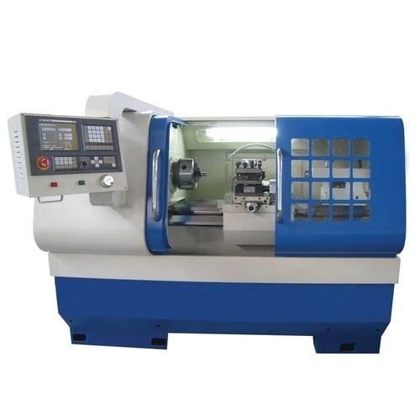**Different Operation Performed on Lathe Machine:**

* Turning Operation
* Tapered Turning
* Shoulder Turning
* Facing Operation
* Thread cutting operation
* Parting Operation
* Chamfering Operation
* Knurling Operation
* Drilling Operation
* Boring Operation
* Counter Boring Operation
* Countersinking Operation and
* Reaming Operation

# ***Milling Machine***

The milling machines are also known as the multi-tasking machines (MTMs) which are multi-purpose machines capable of milling and turning the materials as well. The milling machine has got the cutter installed up on it which helps in removing the material from the surface of the work piece. When the material gets cooled down then it is removed from the milling machine.

## ***Milling Process***

The milling machine involves the following processes or phases of cutting:

### ***Milling Cutters***

There are a lot of cutting tools used in the milling process. The milling cutters named end mills have special cutting surfaces on their end surfaces so that they can be placed onto the work piece by drilling. These also have extended cutting surfaces on each side for the purpose of peripheral milling. The milling cutters have small cutters at the end corners. The cutters are made from highly resistant materials that are durable and produce less friction.

### ***Surface Finish***

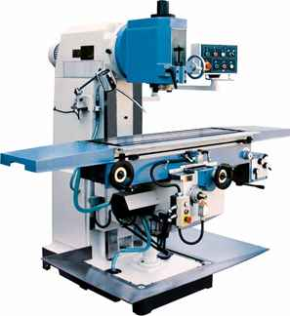Any material put through the cutting area of the milling machine gets regular intervals. The side cutters have got regular ridges on them. The distance between the ridges depends on the feed rate, the diameter of the cutter and the quantity of cutting surfaces. These can be the significant variations in the height of the surfaces.

### ***Gang Milling***

This means that more than two milling cutters are involved in a setup like the horizontal milling. All the cutters perform a uniform operation or it may also be possible that the cutter may perform distinct operations. This is an important operation for producing duplicate parts.

## ***Types of Milling Machines***

### *****Vertical Milling Machines*****

The vertical mill has a vertically arranged spindle axis and rotate by staying at the same axis. The spindle can also be extended and performing functions such as drilling and cutting. Vertical mill has got two further categories as well: turret mill and bed mill.

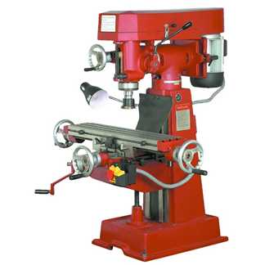The turret mill has got a table that moves perpendicularly and parallel to the spindle axis in order to cut the material. The spindle is, however, stationary. Two cutting methods can be performed with this by moving the knee and by lowering or raising the quill. The other is the bed mill in which the table moves perpendicular to the axis of the spindle and the spindle moves parallel to its axis.

### *****Horizontal Milling Machines*****

[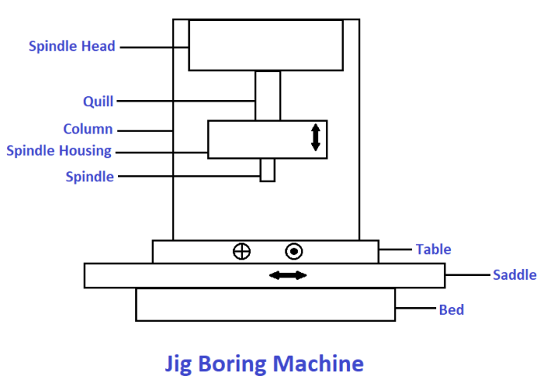](https://i1.wp.com/www.theengineerspost.com/wp-content/uploads/2020/07/Jig-Boring-Machine-1.png?resize=696,499&ssl=1)The horizontal mill is also the similar cutter but their cutters are placed on a horizontal arbor. A lot of horizontal mills have got rotary tables that help in milling in various angles. These tables are called the universal tables. Apart from this all the tools that are used in a vertical mill can also be used in the horizontal mill.

# *Jig Boring Machine*

Jig boring machine is used for the production of [jigs, fixtures](https://www.theengineerspost.com/jigs-and-fixtures/), tools, and other parts. That requires a high degree of accuracy. They are defined by terms of highest accuracy through rigidity, low thermal expansion, and precise means of measuring distance for locating and spacing holes.

The machining accuracy is high, within a range of 0.0025 mm. A jig boring machine looks like a [vertical milling machine](https://www.theengineerspost.com/15-different-types-of-milling-machines/). But so far its operation and accuracy are concerned that there cannot be any comparison between the two.

The spindle and other parts of the machine are much hard to resist deflection and the vibration is low. A Spindle runs in preloaded [antifriction bearings](https://www.theengineerspost.com/types-of-bearing/). The spindle housings are made of invar having a very low coefficient of linear expansion.

Jig boring machines need to be operated in temperature-controlled rooms where the temperature can be kept constant. This is essential to prevent inaccuracy in the machine and in the work being manufactured due to the thermal expansion of the metal.

*Parts of a Jig Boring Machine*

***1. Head-stock***

It is also called the spindle head; it is fixed on the column in the front. The spindle is held in the shaft. As this shaft is moving upward and downward it becomes more like a telescopic mechanism.

***2. Column***

[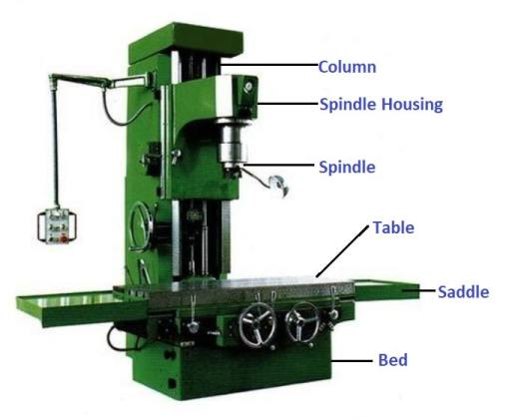](https://i1.wp.com/www.theengineerspost.com/wp-content/uploads/2020/07/Jig-borer-min.jpg?resize=507,420&ssl=1)It is also a hollow component made of cast iron. It is supporting the headstock, guideways and vertical head gives axis for positioning.

***3. Bed***

The tools on which the machine is grounded is called a bed. It is made of cast iron which supports the pillar, saddle, control penal, and the whole machine.

***4. Pick-up Devices***

It is connected to the table and saddle. It is helping to control various machine operations automatically.

***5. Table and Saddle***

The table helps to fasten and hold the workpiece in a fixture in the required position. So it has T-shaped slots built into it. The saddle gives the longitudinal motion to the workpiece.

*Working Principle of Jig Boring Machine*

Jig boring machine works on the principle of feed in the vertical axis of the hole and its radius. In this process rotating tool is moved over the process is given with respect to static work.

This principle is used for large workpieces. Whereas the small size workpiece tool is kept stable and the work is done by applying force. Jig boring is a unique type of boring process. So its working principle is similar to the boring process.

*Types of Jig Boring Machine*

***1. Vertical Milling Machine Type***

It relates in construction to a vertical milling machine. The spindle rotates on a vertical column and the horizontal table rests on the bed in front of the column.

The position of the work mounted on the table. It may be taken by compound moves of the table, perpendicular, and parallel to the column face.

***2. Planer Type***

It has two vertical columns on the two sides of the table and is fixed on the base. The table has a reciprocating action for adjustment of the work. The spindle is fixed on the crossrail bridging the two vertical columns.

In a planer type jig borer, two co-ordinate movements for hole location are given. By the longitudinal movement of the table and the cross movement of the spindle along the crossrail.

*Methods of Locating Holes in Jig Boring*

Holes should be bored on jigs and fixtures at distances from the two straight sides of the work. Exact positioning is essential for producing accurate jigs, fixtures, dies, etc.

***1. Leadscrew Method***

The leadscrew method is the most common and quick method of placing the work below the spindle.

Both longitudinal and crossfeed leadscrews are rotated by a specified value. Any error in the leadscrew due to backlash, wear, or manufacturing fault may be set by using a compensating device.

***2. Mechanical and Electrical Gauging Method***

Mechanical gauges such as gauge blocks or end measures are placed against a stop on the table. And a dial indicator is fitted at the outer end of the trough.

The motion of the table is now directed by the length of the end measures. The table may be set both in a longitudinal and crosswise direction to locate the exact hole. Electrical gauging devices are also sometimes used.

***3. Optical Measuring Method***

The scales used for measuring the motion of the table are enclosed within the machine to stop it from any harm or wear.

The motion of the table is set by the leadscrew or by hydraulic means. But the position of the table along the two axes is done by using the scale which may be seen through a microscope.

*Specification of Jig Boring Machine*

1. It has a maximum distance between the spindle face.
2. The distance of the spindle axis from the column.
3. The minimum distance between spindle, face table & various spindle speeds.
4. [Least count of vernier caliper](https://www.theengineerspost.com/types-of-vernier-caliper/).
5. The minimum measuring capacity of a dial.
6. Horsepower of the table feed motor.
7. Horsepower of the main motor.
8. A maximum table transverse.
9. The dimension of the working axis of the table.
10. A maximum weight of work which can be placed.

*Jig Boring Operations*

The jig boring machines are made to produce precision dies, [gauges](https://www.theengineerspost.com/gauges-types/), and jigs. They can also be used as a measuring machine to check up a job already manufactured in other machines.

Workpieces are clamped on the table by T-bolts and straps. And single point boring tools are used for enlarging holes. [Single-point tools](https://www.theengineerspost.com/lathe-cutting-tools/) are favored than multipoint tools. As a single point tool allows maximum accuracy in locating holes and offers a better surface finish.

*Applications of Jig boring Machine*

1. The jig borer is used for the pilot hole.
2. It is used to make compound and progressive dies.
3. It is also used for [drilling](https://www.theengineerspost.com/types-of-drilling-machine/) holes in jig-bushing.
4. Jig borer is commonly used for jigs, fixtures and dies & bushing hole for grinding & A [grinding the hardened parts](https://www.theengineerspost.com/what-is-grinding/).
5. Also used in alignment post in stripper or die set.

# ***Investment Casting(Lost Wax Casting)***

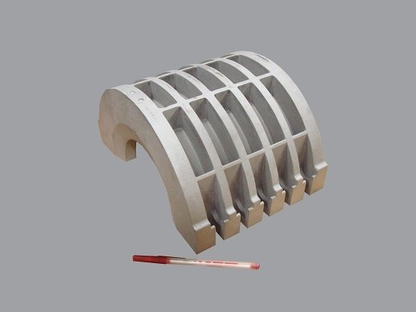Factors such as design requirements, cost, and feasibility to manufacture dictate which casting process is most suitable to manufacture a product. This article describing investment casting is intended to help you make an informed casting decision.

Investment casting produces precise components while minimizing material waste, energy, and subsequent machining. It can also ensure the production of very intricate parts. This makes the investment casting process quite useful to design engineers.

The term “invested” historically carries the meaning of “clothed” or “surrounded.”  Investment casting employs a shell made of ceramic, plaster, or plastic that is formed around a wax pattern. The wax pattern is melted and removed in a furnace and metal is poured into the shell to create the casting.

*The Investment Casting Process*

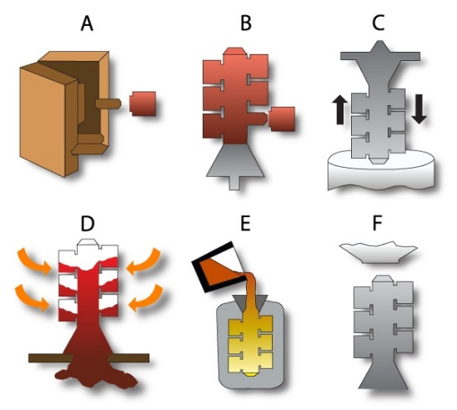

*A.Creating The Pattern*

It utilizes a pattern with the same details as the finished part, except that there is an allowance for thermal contraction (i.e. shrinking). Patterns are typically made of wax using a metal injection die.

*B. Mounting The Wax Patterns and Creating the Tree*

Once a wax pattern is produced, it is assembled with other wax components to form the gate and runner metal delivery system. Depending on the size and configuration of the desired finish component, multiple wax patterns may be processed using a single tree.

*C. Creating The Mold Shell*

The entire wax pattern assembly is dipped in a ceramic slurry, covered with sand stucco, and allowed to dry. Cycles of wet dipping and subsequent stuccoing are repeated until a shell of the desired thickness is created. That thickness is partly dictated by product size and configuration.Once the ceramic shell has dried, it becomes sufficiently strong to retain the molten metal during casting.

*D. Wax Removal*

The entire assembly is placed in a steam autoclave to melt away most of the wax.Any remaining wax soaked into the ceramic shell is burned out in a furnace. At this point, the residual wax pattern and gating material have been completely removed and the ceramic mold remains with a cavity in the shape of the desired cast part.This high-temperature operation also increases the strength and stability of the ceramic material. In addition, it helps to minimize the reaction of the shell and metal during pouring.

*E. Melt and Cast*

The mold is preheated to a specific temperature and filled with molten metal, creating the metal casting.Nearly any alloy can be produced using this process. Either air melting or vacuum melting may be employed as dictated by the alloy chemistry. Vacuum melting is utilized mainly when reactive elements are present in the alloy.

*F. Final Operations*

Once the casting has cooled sufficiently, the mold shell is broken away from the casting in a knockout operation.The gates and runners are cut from the casting, and if necessary, final post-processing sandblasting, grinding, and machining is performed to finish the casting dimensionally.Non-destructive testing may include fluorescent penetrant, magnetic particle, radiographic, or other inspections. Final dimensional inspections, alloy test results, and NDT are verified prior to shipment.

*Advantages of Investment Casting Process*

*Size Range:*

Although most investment castings are small, the investment process can produce castings weighing more than 1,000 pounds. This capability is limited to a relatively small number of investment casters and requires special expertise in handling. Most cast parts fall in the ounces to a 20-pound range.

*Versatile and Intricate Shapes:*

Investment casting provides consistent and repetitive close tolerances along with intricate passages and contours. Many of these configurations are impossible to produce. For example, where machine tools cannot reach. Achieving net-shape or near-net-shape cast components can dramatically reduce post-cast processing costs.

Investment casting is a good alternative to weldments or fabricating. Many components can be combined into a single casting. The more that are combined, the better the manufacturing efficiency. Converting multi-piece components to a single investment casting typically delivers more dimensional accuracy and reduced part complexity.

*Accurate and Smooth Surfaces:*

The ceramic shell used is built around smooth patterns produced by injecting wax into a polished aluminum die. A 125 micro finish is standard, and even finer finishes are not uncommon.

Investment castings contain no parting line because only one mold is used rather than two half molds (such as in the case of [sand casting](https://www.metaltek.com/blog/what-is-sand-casting/)). Standards for surface blemishes and cosmetics are discussed and agreed upon with the customer based on the function.

*Dimensional Accuracy:*

Typically, “standard” investment tolerances are +/-0.010” for the first inch and +/- 0.004” for each succeeding inch.

The design phase can result in a drawing that reduces or even eliminates previous machining requirements to produce the same part.

The cost of any part increases in proportion to the preciseness of its dimensional requirements. Whether if it’s castings machined parts or fabrications. A close design review will permit modification to tolerances, undercuts, blind holes, etc. to allow higher production yields and lower piece costs. If closer than cast tolerances are necessary, the machining required for investment casting will be less than conventional castings or fabricated components.

*Quality and Integrity:*

Casting integrity is an important feature of the process. Investment casting has a long history of serving demanding sectors such as [gas turbine engine](https://www.metaltek.com/market-solutions/turbine-engine/), petroleum, chemical, [defence](https://www.metaltek.com/market-solutions/defense/), and medical.

*Considerations When Using Investment Casting*

*Tooling Cost:*

For low quantity requirements, it may be more expensive than other methods if permanent tooling is pursued. For those applications, [SLA](https://www.metaltek.com/capabilities/metallurgy-engineering/) or printed patterns may be a cost-effective alternative (even for a quantity of one).

Initial costs are another key factor when determining whether investment casting brings the greatest value. The investment cast tool usually consists of multiple parts fitted together to produce the complex components. This “front end” cost is not insignificant but can be easily offset by the lack of subsequent machining and/or fabrication.

*Size Limitations:*

It’s possible to create investment castings in a range of sizes. There is an upper limit on that range, which is less than other shaped technologies like sand casting.

*Very Small Structures:*

Investment casting is an excellent choice for thin-walled applications, but very small internal shapes that use cores can present challenges. Holes typically cannot be smaller than 1/16” (1.6mm) or deeper than 1.5 times in diameter.

*Timing:*

The multi-step investment casting process is more time consuming than other processes. The processing time can be shorter than other alternatives.

# ***Electric Starting Systems and Starter Generator Starting System***

Electric starting systems for gas turbine aircraft are of two general types: direct cranking electrical systems and starter generator systems. Direct cranking electric starting systems are used mostly on small turbine engines, such as Auxiliary Power Units (APUs), and some small turboshaft engines. Many gas turbine aircraft are equipped with starter generator systems. Starter generator starting systems are also similar to direct cranking electrical systems except that after functioning as a starter, they contain a second series of windings that allow it to switch to a generator after the engine has reached a self-sustaining speed. This saves weight and space on the engine.

The starter generator is permanently engaged with the engine shaft through the necessary drive gears, while the direct cranking starter must employ some means of disengaging the starter from the shaft after the engine has started. The starter generator unit is basically a shunt generator with an additional heavy series winding. [Figure 5-16] This series winding is electrically connected to produce a strong field and a resulting high torque for starting. Starter generator units are desirable from an economic standpoint, since one unit performs the functions of both starter and generator. Additionally, the total weight of starting system components is reduced and fewer spare parts are required.

# ***CNC:***

Numerical control (also computer numerical control, and commonly called CNC) is the automated control of machining tools (such as drills, lathes, mills and 3D printers) by means of a computer. A CNC machine processes a piece of material (metal, plastic, wood, ceramic, or composite) to meet specifications by following a coded programmed instruction and without a manual operator directly controlling the machining operation.

A CNC machine is a motorized maneuverable tool and often a motorized maneuverable platform, which are both controlled by a computer, according to specific input instructions. Instructions are delivered to a CNC machine in the form of a sequential program of machine control instructions such as G-code and M-code, then executed. The program can be written by a person or, far more often, generated by graphical computer-aided design (CAD) software and/or computer aided manufacturing (CAM) software. In the case of 3D printers, the part to be printed is "sliced", before the instructions (or the program) is generated. 3D printers also use G-Code.

## *CNC in Aviation*

Aircraft carriers, from two-person private jets to commercial airplanes that carry a few hundred passengers around the globe, must be constructed with the utmost precision. This precision includes all facets of production, from the engine of the aircraft to the outer body of the jet. A CNC machine can play a critical role in quickly and precisely manufacturing specific tools that aid in the operations of each plane component. For example, in order for a plane’s engine to maintain an 8-hour flight, it must be designed to properly process and utilize the fuel inside it. A barely visible piece within the engine may be created with a CNC machine. The same may be said for the plane’s cockpit, which likely includes an intricate computer system to ensure the plane reaches its intended destination. In addition to these inner workings of a jet, the outside design like a plane’s wing could be modified with a CNC machine with extreme precision so that the wing functions through the air properly and efficiently.

## *Aerospace applications for CNC Machining*

Considering that an aircraft is made up of millions of components, it is not surprising that many manufacturing methods are used in their production: from sheet metal fabrication and molding to advanced manufacturing processes like 3D printing and CNC machining.

Within the scope of CNC machining, 5-axis machining is commonly used for the production of complex aircraft components, as it allows for parts to be milled, drilled and manipulated along the X, Y, Z and linear axes simultaneously without having to reconfigure or refixture the part. Why is complexity an asset in the aerospace sector? In short: weight. Being able to produce a part with a partially hollowed out or complex geometry can reduce its weight without sacrificing quality or performance.

Paired with sophisticated design and workflow software and state-of-the-art inspection processes, CNC machines can produce end-use parts and high quality tooling components for aerospace manufacturers. Though it would be impossible to list all the parts that are produced using CNC machining, some significant examples include hydraulic manifolds, transmissions, fuel bodies, landing gear, electrical connectors, housings and more.

CNC machining doesn’t only have an important role in the production of aircraft end-use parts; it plays a key part in aerospace R&D, enabling aerospace companies—big or small—to rapidly iterate new component designs, test them and, if needed, edit them. Rapid prototyping services such as RapidDirect can work with aerospace companies and OEMs to deliver CNC machined prototypes and parts within as little as three days with tolerances down to 0.002 mm.

# **ER Diagram:**

# **Tool Requirements:**

1.Visual Studio 2013

2.Web Browser

# **Code:**

**hal.html**

1. <!DOCTYPE html>
2. <html>
3. <head>
4. <title>Hindustan Aeronautics Limited</title>
5. <link rel="stylesheet" href="halcss.css" />
6. </head>
7. <body>
8. <img src="hal1.jpg" class="img1" align="middle" width="1100" height="130" /><br />
10. <div class="dropdown">
12. <button class="dropbtn"><i>About</i></button>
14. <div class="dropdown-content">
15. <a style="font-size:20px;" href="engine division.html"><i>Engine Division</i></a><br />
16. <a style="font-size:20px;" href="sukhoiengine.html"><i>Sukhoi Engine Division</i></a><br />
17. <a style="font-size:20px;" href="Sunabeda.html"><i>Sunabeda</i></a><br />
18. </div>
19. </div>
20. <div class="dropdown">
21. <button class="dropbtn"><i>Learning Resources</i></button>
22. <div class="dropdown-content">
23. <a style="font-size:20px;" href="pdf.html"><i>Learning Resources</i></a><br />
24. </div>
25. </div>
26. <div class="dropdown">
27. <button class="dropbtn"><i>Departments</i></button>
28. <div class="dropdown-content">
29. <a style="font-size:18px;color:black;" href="IT.html"><i>IT</i></a><br />
30. <a style="font-size:18px;color:black;" href="admin.html"><i>Admin</i></a><br />
31. <a style="font-size:18px;color:black;" href="hr.html"><i>HR</i></a><br />
32. <a style="font-size:18px;color:black;" href="overhaul.html"><i>Overhaul</i></a><br />
33. <a style="font-size:18px;color:black;" href="cpp.html"><i>CPP</i></a><br />
34. <a style="font-size:18px;color:black;" href="civil.html"><i>Civil</i></a><br />
35. <a style="font-size:18px;color:black;" href="foundry.html"><i>Foundry and Forge</i></a><br />
36. </div>
37. </div>
38. <div class="dropdown">
39. <button class="dropbtn"><i>Contact</i></button>
40. <div class="dropdown-content">
41. <a style="font-size:20px;" href="contact.html"><i>Contact</i></a><br />
43. </div>
44. </div>
45. <div><h2><i>Engine Division</i></h2></div>
46. <p style="font-size:20px">
47. <i>
48. Engine Divion,Koraput was established in the year <b>1964</b> to manufacture
49. <b>R11F2-300</b> Sr III Engine for fitment in <b>MiG-21FL </b>Aircraft under
50. lisences fron erstwhile USSR . In <b>1976</b> facilities were established to
51. manufacture <b>R25</b> Engines for fitment in <b>MiG-21BIS</b> Aircraft.
52. Subsequently division also manufactured R29b and RD33 Engines under lisences
53. from Russia.<br />Since the early <b>1970</b>,overhauling facilities were
54. established in the division and division has been overhauling Aero Engines
55. of various types i.e . <b>R11,R25,R29 and RD33</b> which power <b>
56. MiG-21FL,
57. MiG-21BIS,MiG-27 and MiG-29
58. </b> respectively .Over last five decades division
59. has manufactured more than <b>1300</b> engines and overhauled more than
60. <b>7000</b> Aero Engines of various types with an aim to ensure maximum
61. aircrafts flying.
62. </i>
63. </p>
64. <div>
65. <h2><i>Sukhoi Engine Division</i></h2>
66. </div>
67. <p style="font-size:20px">
68. <i>
69. Sukhoi Engine Division , Koraput established in the year 2004 to
70. manufacture AL31FP Engines for fitment in Su-30MKI under lisence
71. from Russia . In 2007-2008 facilities are established for overhauling
72. of AL31FP Engines under lisence from Russia.
73. </i>
74. </p>
75. <h2> <i>AL31FP Manufacturing & Overhaul Project</i></h2>
76. <p style="font-size:20px">
77. <i>
78. Progress of manufacturing and overhaul works is reviewed through latest
79. IT enabled systems ensures timely completion of assemblies and
80. sub-assemblies of the engines. The stripped components are subject to
81. stringent quality checks using modern technology like CMM, NDT and other
82. non-contact measurements. Manufacturing, Repair and refurbishing of worn-out
83. parts and sub-assemblies are undertaken by skilled workmen. In 2007-08 facilities were established for overhauling of
84. AL31FP Engines under licence from Russia.
85. Over last five decades, Division has manufactured more than 350 engines and
86. overhauled more than 300 Aero Engines with an aim to ensure maximum aircrafts
87. flying.<br /> Division is also manufacturing most of the components in-house,
88. which are required during overhaul. Manufacturing, Repairs and Refurbishing
89. Processes include machining, welding, hard alloy coatings, vibro-tumbling, micro-shot peening, ultrasonic strain hardening, nickel alloy powder
90. coating and a large number of protective coatings. Assemblies, sub-assemblies and Engine accessories undergo rigorous functional tests on
91. various Hydraulic, Fuel and Electrical Rigs. Quality control checks are carried out using various NDT methods, like X-ray, Magna-flux,
92. Dye-penetrant check and ultrasonic inspection besides other conventional techniques. Overhaul of accessories is carried out in environmentally
93. controlled rooms. Every manufactured / overhauled Engine undergoes rigorous tests on Engine test beds that simulate all flight conditions.
94. The preliminary and final acceptance test, hot test, endurance test and gas dynamic stability tests are conducted through computerized controls.
95. Electronically assisted throttle, digital and analog read-outs help get real-time simultaneous data and engine parameters during Engine testing.
96. </i>
97. </p>
98. <h2><i>TBO and TTL of AL31FP Engine is:</i></h2>
99. <div>
100. <img src="tbottlofal31fp.jpg" class="img1" width="700" height="150" />
101. </div>
102. <h2><i>Rotables:</i></h2>
103. <p style="font-size:20px">
104. <i>
105. In addition to Engine IAF gives us additional task to overhaul Rotables. There are more than30 types of Rotables which are being overhauled in-house.
106. All these Rotables undergo vigorous Quality checks and testing procedure before being released to bases for exploitation.
107. </i>
108. </p>
109. <h2><i>Supply of Spares and other major units:</i> </h2>
110. <p style="font-size:20px"><i>The Division manufactures and supplies the entire range of spares required for first and second-line servicing of engines at the IAF bases and base repair depots.</i></p>
111. <h3><b>Site Repair:</b></h3>
112. <p style="font-size:20px"><i>The Division undertakes site repair of Engines at the IAF bases by deputing site repair teams regularly.</i></p>
113. <h2><i>Defect Investigation/Failure Analysis:</i> </h2>
114. <p style="font-size:20px">
115. <i>
116. The Engines / Aggregates which are received due to premature withdrawal from the units are studied and the causes for defects/failures are investigated. After proper analysis
117. and deliberation, corrective action is taken to minimize the recurrence of defects in future.
118. </i>
119. </p>
120. <h2><i>Workshops:</i></h2>
121. <p style="font-size:20px"><i>The Division conducts workshops regularly to the customers at Koraput in specialized areas for better understanding and utilization of the products.</i></p>
122. <h2><i>Positioning of Service Engineers:</i></h2>
123. <p style="font-size:20px">
124. <i>
125. The Division has posted Service Engineers at various <b>IAF</b> bases to closely liaise and assess the requirement of the customers. Based on the feed-back received
126. from these Service Engineers, the Division renders adequate support for fully utilizing the products.ost of the components in-house, which are required during
127. overhaul. Manufacturing, Repairs and Refurbishing Processes include machining, welding, hard alloy coatings, vibro-tumbling, micro-shot peening, ultrasonic
128. strain hardening, nickel alloy powder coating and a large number of protective coatings. Assemblies, sub-assemblies and Engine accessories undergo rigorous
129. functional tests on various Hydraulic, Fuel and Electrical Rigs. Quality control checks are carried out using various NDT methods, like X-ray, Magna-flux,
130. Dye-penetrant check and ultrasonic inspection besides other conventional techniques. Overhaul of accessories is carried out in environmentally controlled
131. rooms. Every manufactured / overhauled Engine undergoes rigorous tests on Engine test beds that simulate all flight conditions. The preliminary and final
132. acceptance test, hot test, endurance test and gas dynamic stability tests are conducted through computerized controls. Electronically assisted throttle, digital
133. and analog read-outs help get real-time simultaneous data and engine parameters during Engine testing.
134. </i>
135. </p>
136. </body>
137. </html>

# **List of files:**

1. hal.html

2. engine division.html

3. Sunabeda.html

4. sukhoiengine.html

5. IT.html

6. admin.html

7. hr.html

8. overhaul.html

9. cpp.html

10. civil.html

11. foundry.html

12. contact.html

13. pdf.html

14. halcss.css

# **Output:**

Home page:

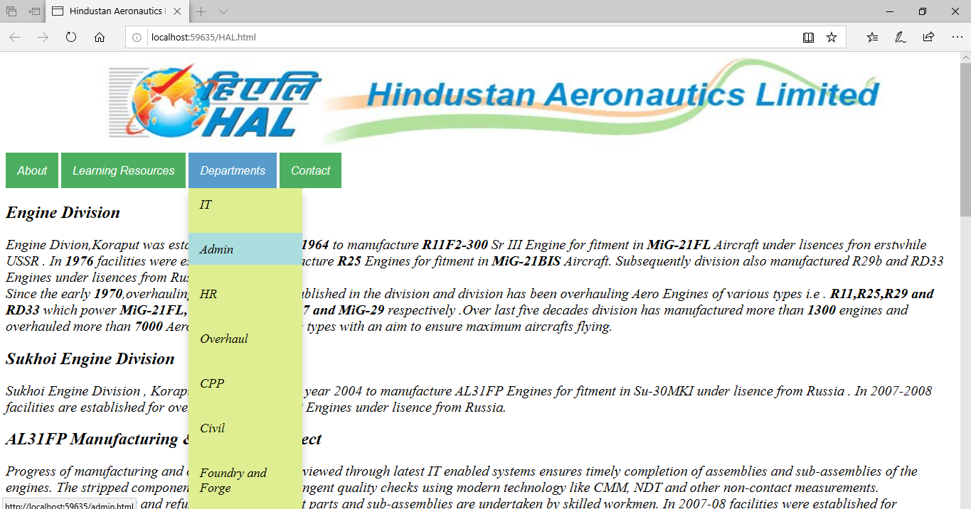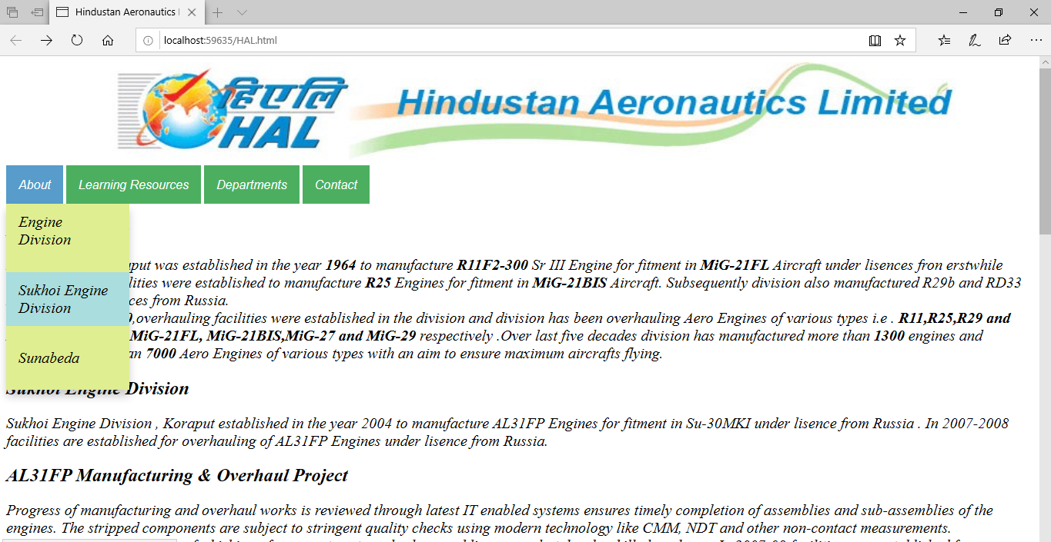

Engine division:

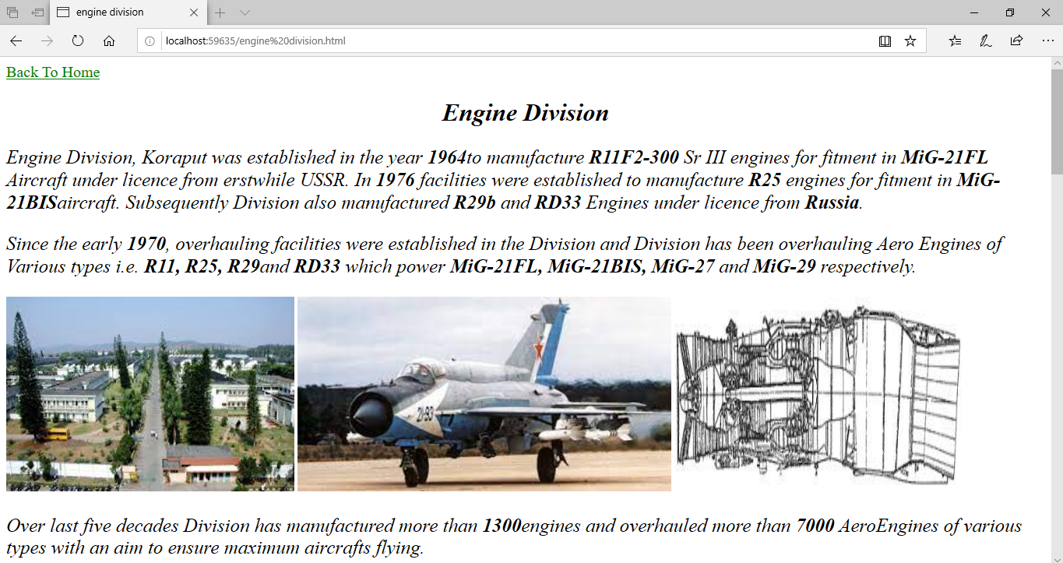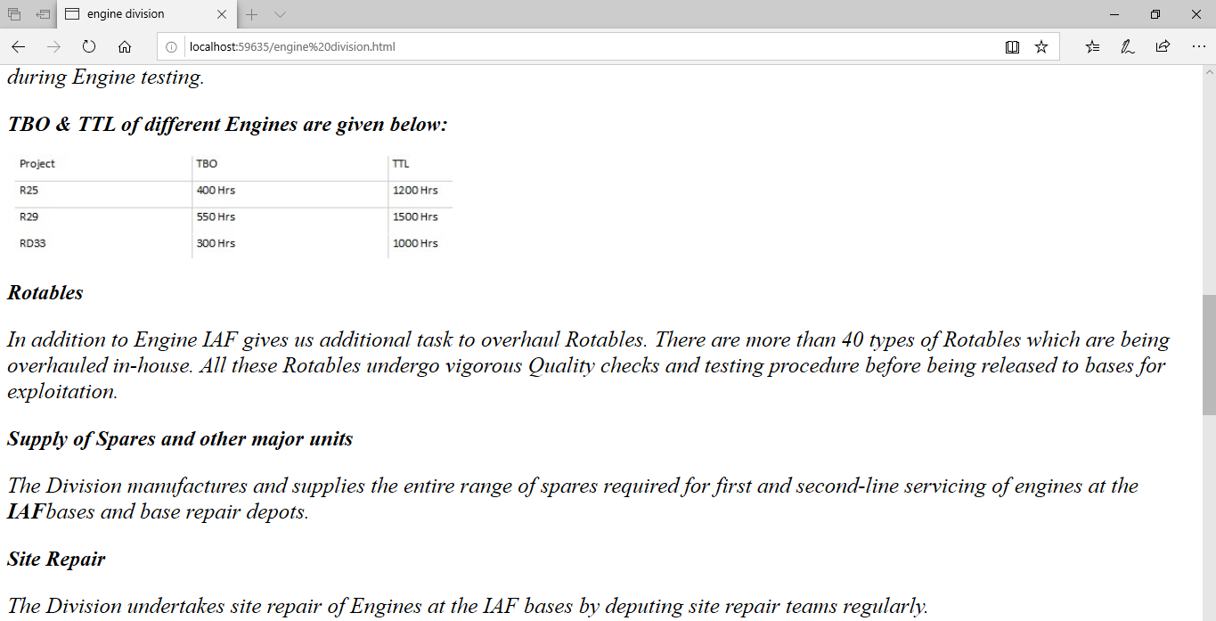

Sukhoi Engine division:

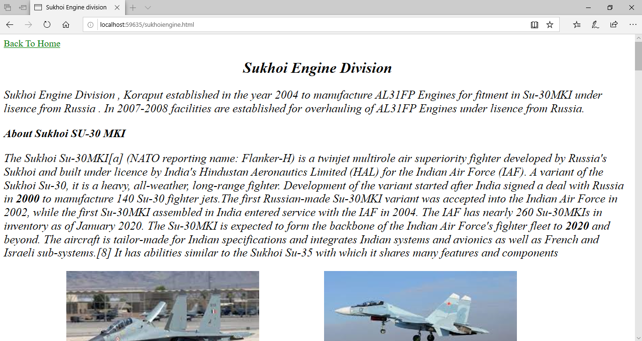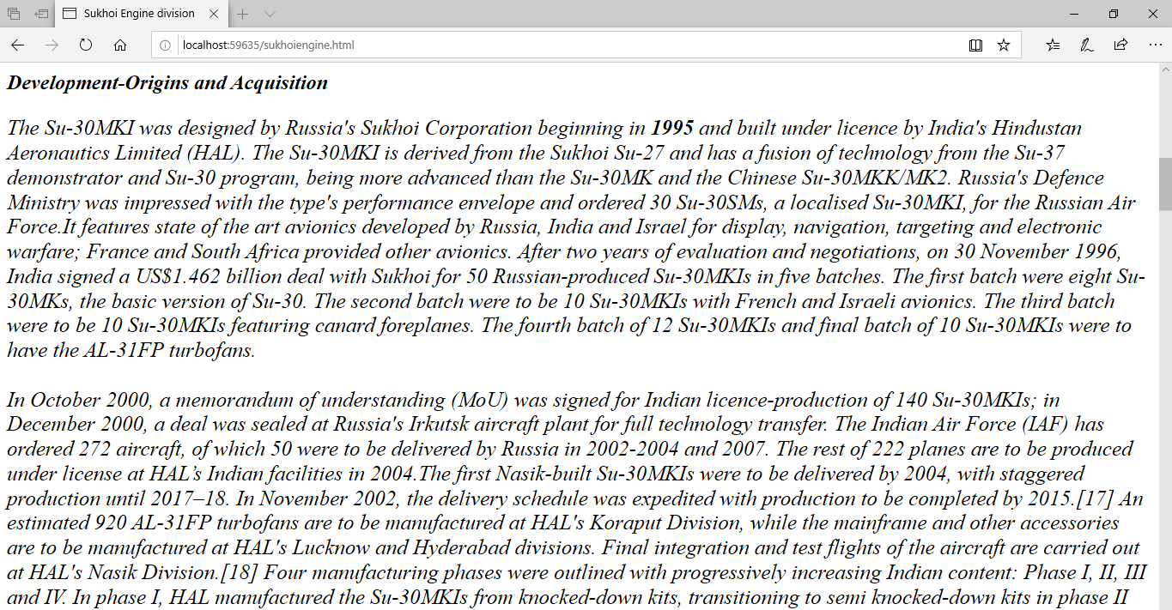

Sunabeda:

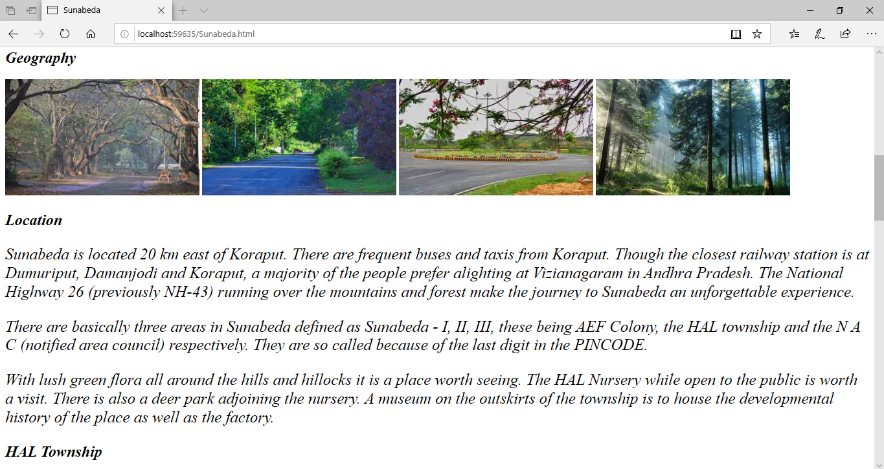

Contact:

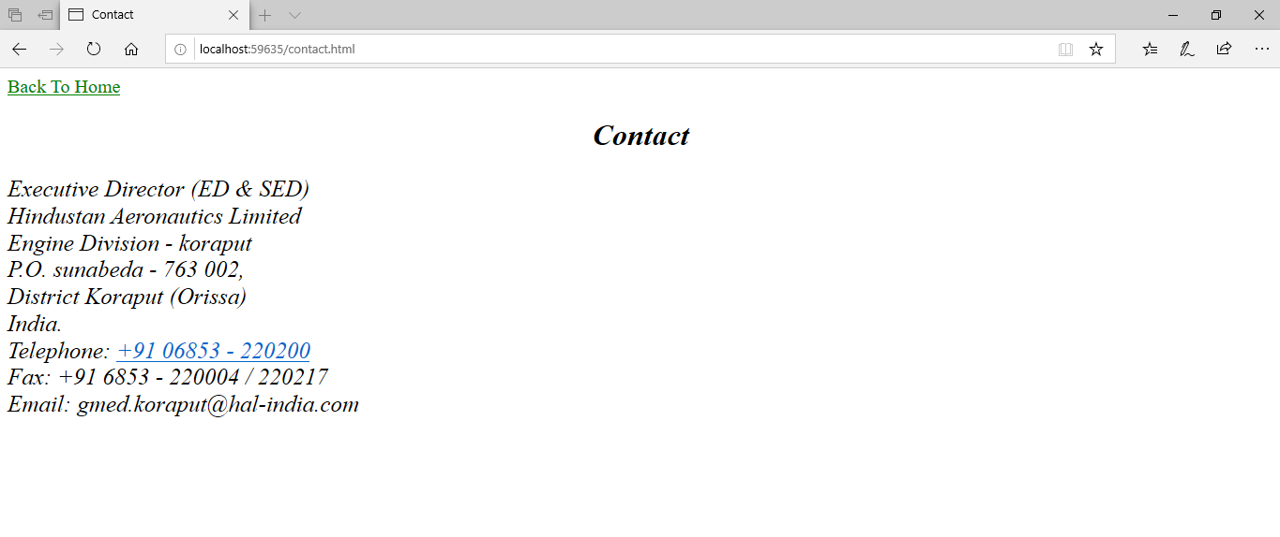

Learning Resources:

# 

IT Department:



Admin Department:



HR Department:



Overhaul:

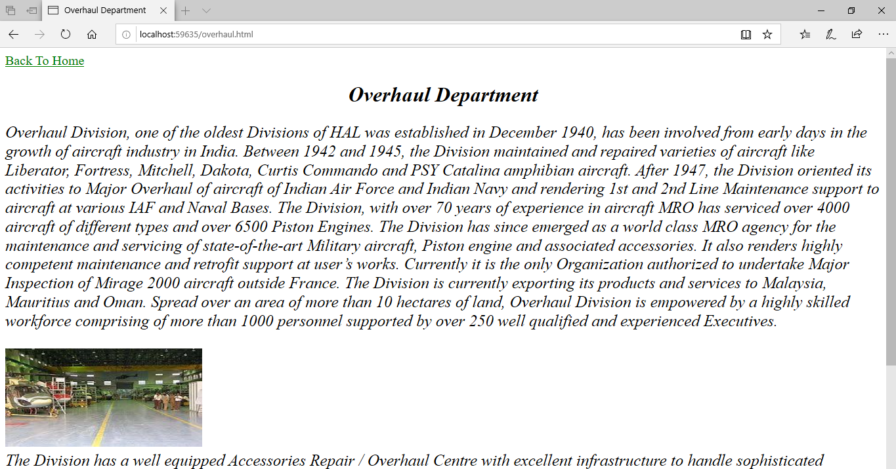

CPP:

# 

Foundry & Forge:

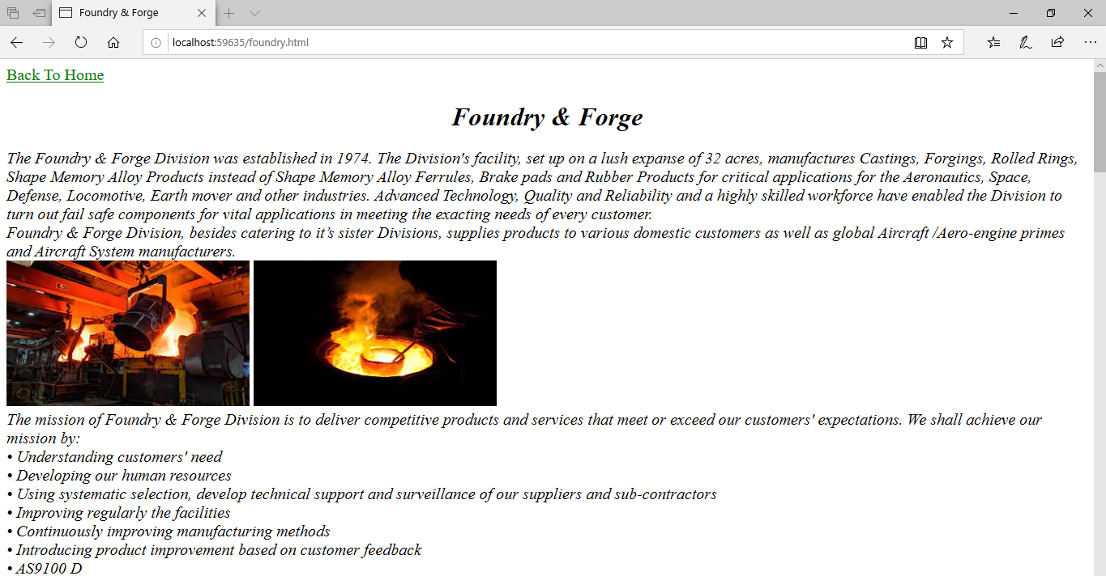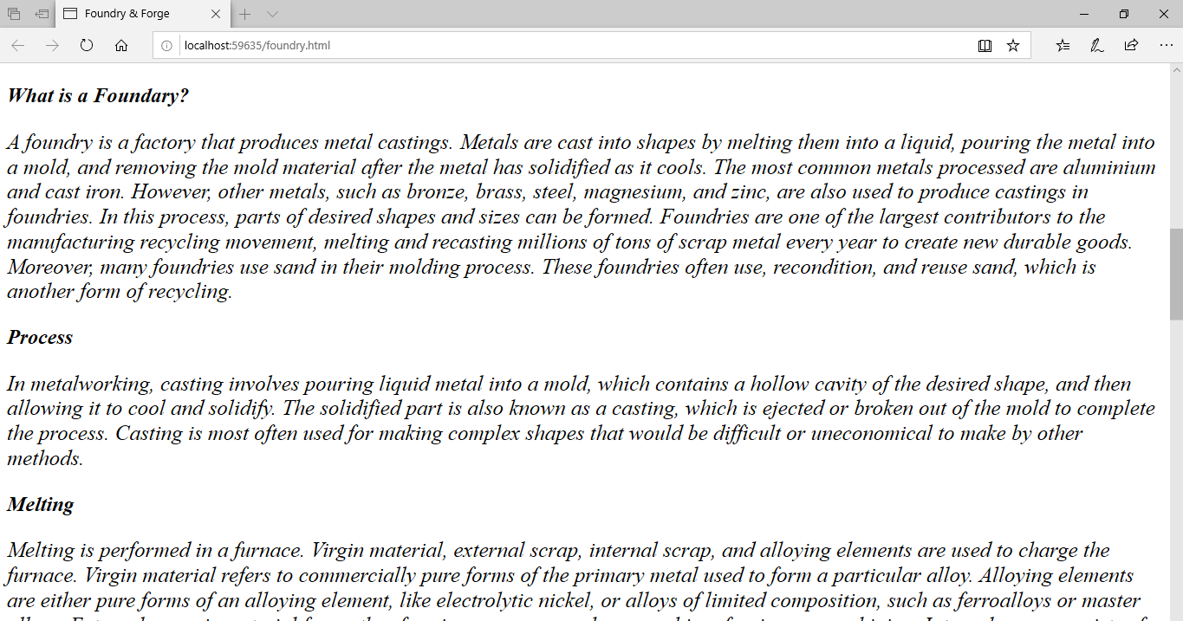

# **Conclusion:**

It would be easier for interns / trainees and staff to get a quick overview about the company, its divisions and its departments. They would get all the necessary information along with resources here that will be useful during their period of training. I have learned about various new terms and terminologies through this project.

***PROJECT: 1***

***NAME OF THE PROJECT: - CSR_GAUGE_SMI_ED_2021***

**CODE FOR CSR_gause_smi_ED_2021.aspx.cs**

using System;

using System.Collections.Generic;

using System.Linq;

using System.Web;

using System.Web.UI;

using System.Web.UI.WebControls;

using DevExpress.Web.ASPxGridView;

public partial class report : System.Web.UI.Page

{

protected void Page_Load(object sender, EventArgs e)

{

//spares

}

protected void ASPxButton1_Click(object sender, EventArgs e)

{

ASPxGridViewExporter1.WriteXlsToResponse();

}

protected void LinkButton1_Init(object sender, EventArgs e)

{

LinkButton link = (LinkButton)sender as LinkButton;

GridViewDataItemTemplateContainer templateContainer = (GridViewDataItemTemplateContainer)link.NamingContainer as GridViewDataItemTemplateContainer;

int rowVisibleIndex = (int)templateContainer.VisibleIndex;

String REQ_NUM = (String)templateContainer.Grid.GetRowValues(rowVisibleIndex, "SL_NO").ToString();

// String status = (String)templateContainer.Grid.GetRowValues(rowVisibleIndex, "STATUS").ToString();

if (REQ_NUM.Length > 0)

{

link.Enabled = true;

}

else link.Visible = false;

}

protected void LinkButton1_Click(object sender, EventArgs e)

{

LinkButton link = (LinkButton)sender as LinkButton;

GridViewDataItemTemplateContainer templateContainer = (GridViewDataItemTemplateContainer)link.NamingContainer as GridViewDataItemTemplateContainer;

int rowVisibleIndex = (int)templateContainer.VisibleIndex;

String REQ_NUM = (String)templateContainer.Grid.GetRowValues(rowVisibleIndex, "SL_NO").ToString();

if (REQ_NUM.Length > 0)

{

Response.Redirect("~/print_CSR_SMI_CERT.aspx?SL_NO=" + ASPxGridView1.GetRowValues(rowVisibleIndex, "SL_NO").ToString());

}

}

}

**CSR_gause_smi_ED_2021.aspx.cs (Screenshot) on ASP.net Platform**

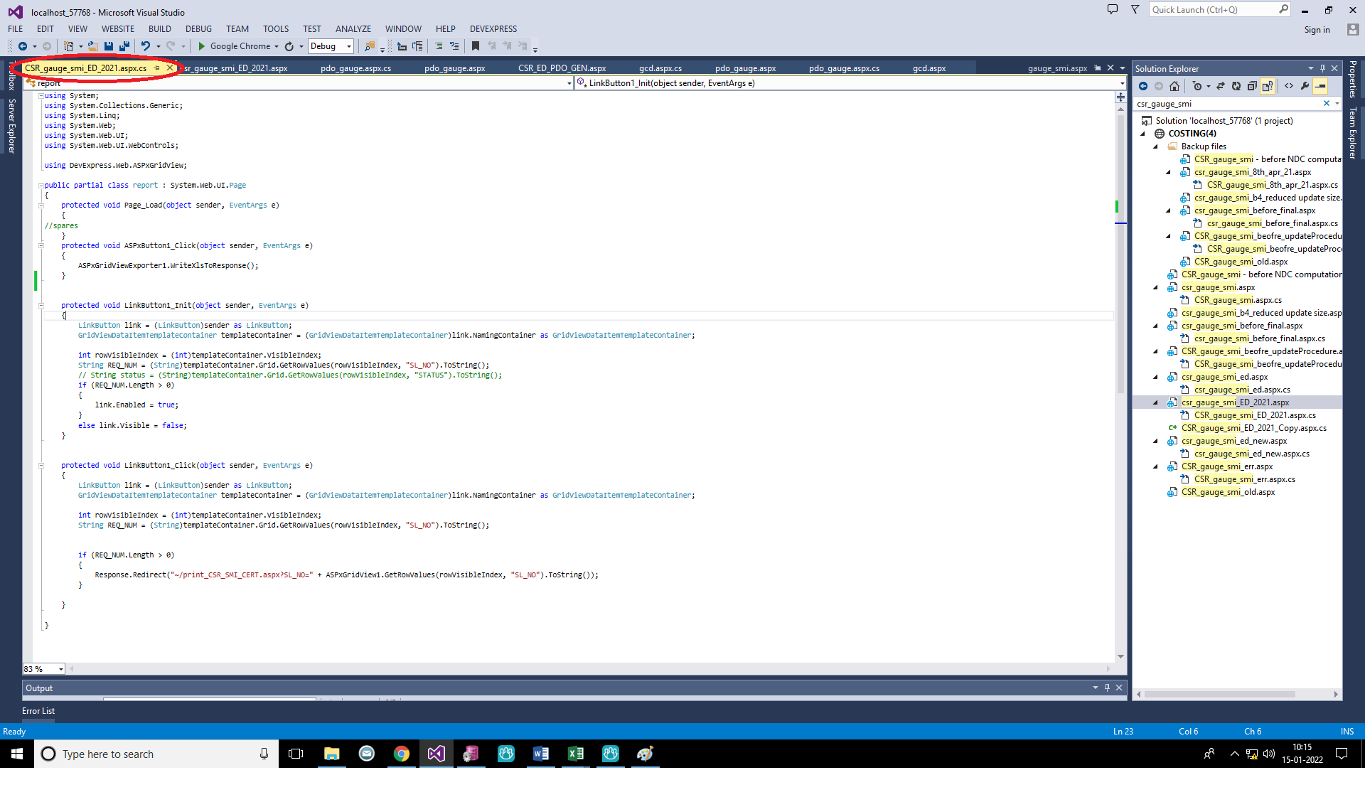

***SCREENSHOT OF OUTPUT SCREEN:-*** OUTPUT SCREEN

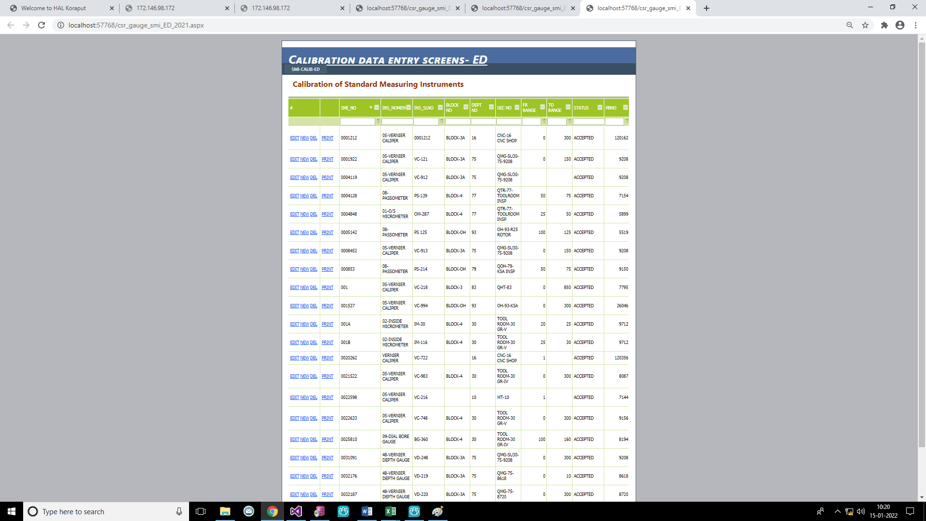

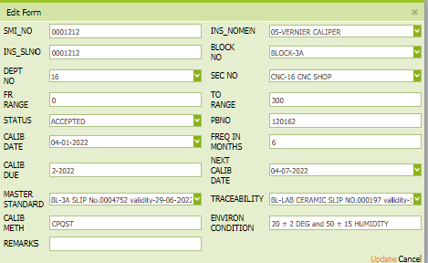After clicking output screen on Edit button then below popup window will be shown like this***.***

After clicking output screen on NEW button then below popup window will be shown like this.

In this new popup window we can put some new value.

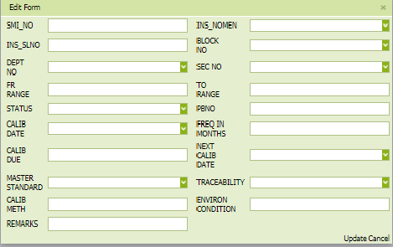

**DATABASE CONNECTION ON ASP.NET**

**BACKEND CONNECTION (PL/SQL)**

@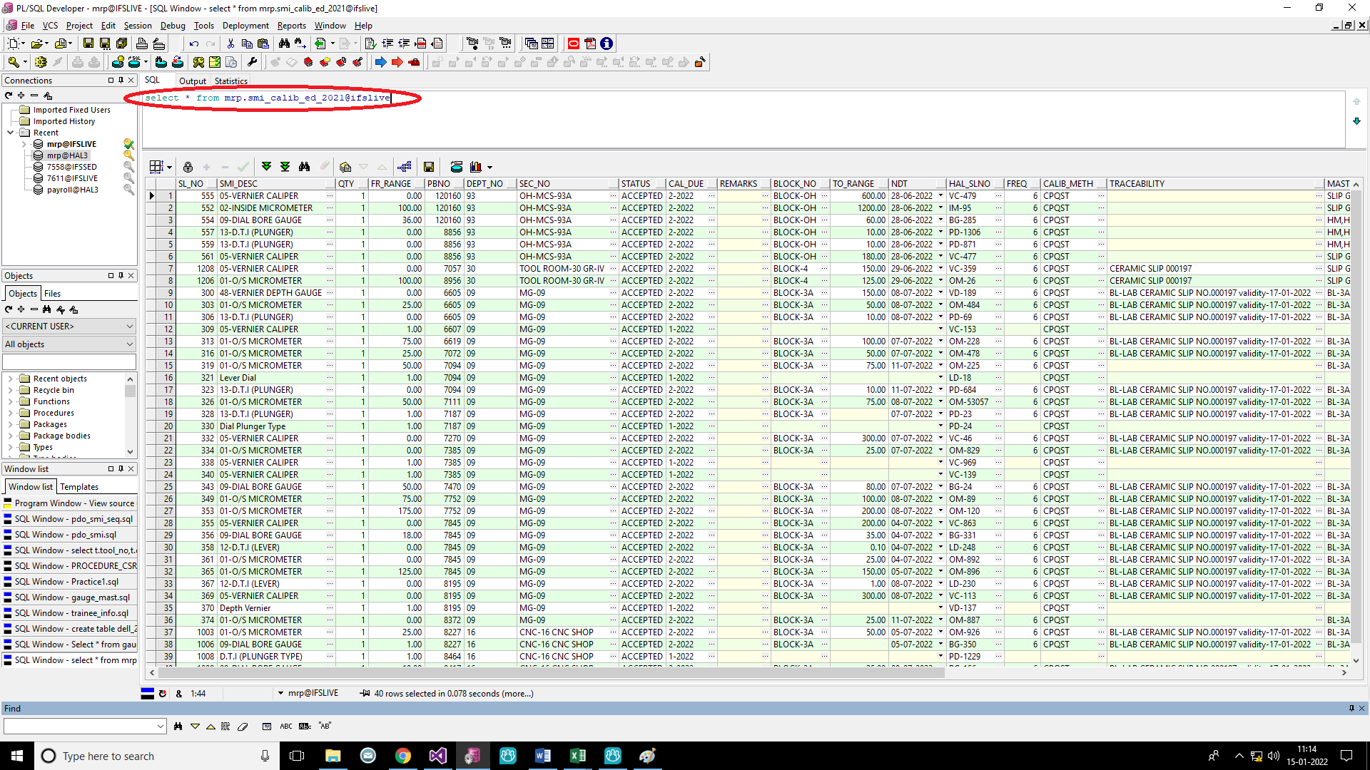

**Name of the Table on PL/SQL database:- CSR_gauge_smi_ed_2021@ifslive**

**csr_gauge_smi_ED_2021.aspx**

<%@ Page Title="" Language="C#" MasterPageFile="~/csr_GAUGE_ED.master" AutoEventWireup="true" CodeFile="CSR_gauge_smi_ED_2021.aspx.cs" Inherits="report" %>

<%@ Register assembly="DevExpress.Web.v13.1, Version=13.1.5.0, Culture=neutral, PublicKeyToken=b88d1754d700e49a" namespace="DevExpress.Web.ASPxGridView" tagprefix="dx"%>

<%@ Register assembly="DevExpress.Web.v13.1, Version=13.1.5.0, Culture=neutral, PublicKeyToken=b88d1754d700e49a" namespace="DevExpress.Web.ASPxEditors" tagprefix="dx" %>

<%@ Register assembly="DevExpress.Web.v13.1, Version=13.1.5.0, Culture=neutral, PublicKeyToken=b88d1754d700e49a"namespace="DevExpress.Web.ASPxGridView.Export"tagprefix="dx" %>

<asp: Content ID="Content1" ContentPlaceHolderID="HeadContent" Runat="Server">

<style type="text/css"

.style1

{

font-size: x-large;

color: #993300;

}

</style>

</asp:Content>

<asp:Content ID="Content2" ContentPlaceHolderID="MainContent" Runat="Server">

<span class="style1">&nbsp; Calibration of Standard Measuring Instruments </span><br />

<br />

<dx:ASPxGridView ID="ASPxGridView1" runat="server" AutoGenerateColumns="False" Font-Size="Small"

DataSourceID="SqlDataSource1" enabletheming="True" Theme="Youthful" KeyFieldName="SL_NO" Width="100%"

ClientInstanceName= "ASPxGridViewHeader" >

<Columns>

<dx:GridViewCommandColumn VisibleIndex="0" Width="100" >

<EditButton Visible="True" Text="EDIT">

</EditButton>

<NewButton Visible="True" Text="NEW" >

</NewButton>

<DeleteButton Visible="True" Text="DEL">

</DeleteButton>

<ClearFilterButton Visible="True" Text="CLEAR">

</ClearFilterButton>

</dx:GridViewCommandColumn>

<dx:GridViewDataTextColumn VisibleIndex="1" Width="60">

<EditFormSettings Visible="False" />

<DataItemTemplate>

<asp:LinkButton ID="LinkButton1" OnInit="LinkButton1_Init" runat="server" OnClick="LinkButton1_Click">PRINT</asp:LinkButton>

</DataItemTemplate>

</dx:GridViewDataTextColumn>

<dx:GridViewDataComboBoxColumn Caption="SL_NO" FieldName="SL_NO" VisibleIndex="1" Visible="false">

</dx:GridViewDataComboBoxColumn>

<dx:GridViewDataTextColumn Caption="SMI_NO" FieldName="SMI_NO" Width="130" VisibleIndex="2">

<EditFormSettings VisibleIndex="0" />

</dx:GridViewDataTextColumn>

<dx:GridViewDataComboBoxColumn Caption="INS_NOMEN" FieldName="SMI_DESC" VisibleIndex="4" Width="100">

<EditFormSettings VisibleIndex="0" />

<PropertiesComboBox Width="250">

<Items>

<dx:ListEditItem Text="01-O/S MICROMETER " Value="01-O/S MICROMETER" />

<dx:ListEditItem Text="02-INSIDE MICROMETER" Value="02-INSIDE MICROMETER" />

<dx:ListEditItem Text="03-DEPTH MICROMETER" Value="03-DEPTH MICROMETER" />

<dx:ListEditItem Text="04-T.P MICROMETER" Value="04-T.P MICROMETER" />

<dx:ListEditItem Text="05-VERNIER CALIPER" Value="05-VERNIER CALIPER" />

<dx:ListEditItem Text="06-HEIGHT GAUGE" Value="06-HEIGHT GAUGE" />

<dx:ListEditItem Text="07-IND. MICROMETER" Value="07-IND. MICROMETER" />

<dx:ListEditItem Text="08-PASSOMETER " Value="08-PASSOMETER " />

<dx:ListEditItem Text="09-DIAL BORE GAUGE" Value="09-DIAL BORE GAUGE" /> <dx:ListEditItem Text="10-BEVEL PROTRACTOR (MECH)" Value="10-BEVEL PROTRACTOR (MECH)" />

<dx:ListEditItem Text="11-BEVELPROTRACTOR (OPTICAL)" Value="11BEVELPROTRACTO(OPTICAL)"/>

<dx:ListEditItem Text="12-D.T.I (LEVER)" Value="12-D.T.I (LEVER)" />

<dx:ListEditItem Text="13-D.T.I (PLUNGER)" Value="13-D.T.I (PLUNGER)" />

<dx:ListEditItem Text="14-MINI COMPARATOR (DIAL)" Value="14-MINI COMPARATOR (DIAL)" />

<dx:ListEditItem Text="15-SINE TABLE" Value="15-SINE TABLE" />

<dx:ListEditItem Text="16-SINE CENTER" Value="16-SINE CENTER" />

<dx:ListEditItem Text="17-V-BLOCK" Value="17-V-BLOCK" />

<dx:ListEditItem Text="18-PARALLEL BLOCK" Value="18-PARALLEL BLOCK" />

<dx:ListEditItem Text="19-ANGLE BLOCK" Value="19-ANGLE BLOCK" />

<dx:ListEditItem Text="20-SQ/RECTANGULAR BLOCK" Value="20-SQ/RECTANGULAR BLOCK" />

<dx:ListEditItem Text="21-ROLLERS" Value="21-ROLLERS" />

<dx:ListEditItem Text="22-SLIP GAUGE" Value="22-SLIP GAUGE" />

<dx:ListEditItem Text="23-SURFACE TABLE C.I" Value="23-SURFACE TABLE C.I" />

<dx:ListEditItem Text="24-PROFILE PROJECTOR" Value="26-PROFILE PROJECTOR" />

<dx:ListEditItem Text="30-MICROSCOPE" Value="30-MICROSCOPE" />

<dx:ListEditItem Text="33-HYGROMETER" Value="33-HYGROMETER" />

<dx:ListEditItem Text="35-HEIGHT MIC MASTER " Value="35-HEIGHT MIC MASTER" />

<dx:ListEditItem Text="41-TORQUE WRENCH" Value="41-TORQUE WRENCH" />

<dx:ListEditItem Text="45-SURFACE TABLE - GRANITE" Value="45-SURFACE TABLE - GRANITE" />

<dx:ListEditItem Text="48-VERNIER DEPTH GAUGE" Value="48-VERNIER DEPTH GAUGE" />

</Items>

</PropertiesComboBox>

</dx:GridViewDataComboBoxColumn>

<dx:GridViewDataTextColumn Caption="INS_SLNO" FieldName="HAL_SLNO" Width="100" VisibleIndex="5">

<EditFormSettings VisibleIndex="0" />

</dx:GridViewDataTextColumn>

<dx:GridViewDataComboBoxColumn Caption="BLOCK<BR>NO" FieldName="BLOCK_NO" VisibleIndex="6" Width="80">

<EditFormSettings VisibleIndex="0" />

<PropertiesComboBox Width="250">

<Items>

<dx:ListEditItem Text="BLOCK-2" Value="BLOCK-2" />

<dx:ListEditItem Text="BLOCK-3" Value="BLOCK-3" />

<dx:ListEditItem Text="BLOCK-3A" Value="BLOCK-3A" />

<dx:ListEditItem Text="BLOCK-4" Value="BLOCK-4" />

<dx:ListEditItem Text="BLOCK-OH" Value="BLOCK-OH" />

<dx:ListEditItem Text="BLOCK-ASSY" Value="BLOCK-ASSY" />

</Items>

</PropertiesComboBox>

</dx:GridViewDataComboBoxColumn>

<dx:GridViewDataComboBoxColumn Caption="DEPT<BR>NO" FieldName="DEPT_NO"

VisibleIndex="6" Width="80">

<EditFormSettings VisibleIndex="0" />

<PropertiesComboBox Width="250">

<Items>

<dx:ListEditItem Text="01" Value="01" />

<dx:ListEditItem Text="02" Value="02" />

<dx:ListEditItem Text="09" Value="09" />

<dx:ListEditItem Text="10" Value="10" />

<dx:ListEditItem Text="11" Value="11" />

<dx:ListEditItem Text="12" Value="12" />

<dx:ListEditItem Text="14" Value="14" />

<dx:ListEditItem Text="15" Value="15" />

<dx:ListEditItem Text="16" Value="16" />

<dx:ListEditItem Text="20" Value="20" />

<dx:ListEditItem Text="30" Value="30" />

<dx:ListEditItem Text="50" Value="50" />

<dx:ListEditItem Text="63" Value="63" />

<dx:ListEditItem Text="75" Value="75" />

<dx:ListEditItem Text="76" Value="76" />

<dx:ListEditItem Text="77" Value="77" />

<dx:ListEditItem Text="78" Value="78" />

<dx:ListEditItem Text="79" Value="79" />

<dx:ListEditItem Text="80" Value="80" />

<dx:ListEditItem Text="81" Value="81" />

<dx:ListEditItem Text="82" Value="82" />

<dx:ListEditItem Text="83" Value="83" />

<dx:ListEditItem Text="93" Value="93" />

<dx:ListEditItem Text="601" Value="601" />

<dx:ListEditItem Text="602" Value="602" />

</Items>

</PropertiesComboBox>

</dx:GridViewDataComboBoxColumn>

<dx:GridViewDataComboBoxColumn Caption="SEC NO" FieldName="SEC_NO" VisibleIndex="8" Width="80">

<EditFormSettings VisibleIndex="0"

<PropertiesComboBox Width="250">

<Items>

<dx:ListEditItem Text="MS-12" Value="MS-12" />

<dx:ListEditItem Text="OH-79 VIEWING" Value="OH-79 VIEWING" />

<dx:ListEditItem Text="QOH-79-EB INSP" Value="QOH-79-EB INSP" />

<dx:ListEditItem Text="QMF-76" Value="QMF-76" />

<dx:ListEditItem Text="QMS-76" Value="QMS-76" />

<dx:ListEditItem Text="STD ROOM-BL-2-77" Value="STD ROOM-BL-2-77" />

<dx:ListEditItem Text="QOH-CBH-79" Value="QOH-CBH-79" />

<dx:ListEditItem Text="OH-79 VIEWING" Value="OH-79 VIEWING" />

<dx:ListEditItem Text="QOH-79-EB INSP" Value="QOH-79-EB INSP" />

<dx:ListEditItem Text="QOH-79-RD33-FS" Value="QOH-79-RD33-FS" />

<dx:ListEditItem Text="QOH-79-RD33-VIEWING" Value="QOH-79-RD33-VIEWING" />

<dx:ListEditItem Text="QOH-79-ROTOR BAY" Value="QOH-79-ROTOR BAY" />

<dx:ListEditItem Text="QOH-79-R25 GB INSP" Value="QOH-79-R25 GB INSP" />

<dx:ListEditItem Text="QOH-MC HE-INSP-79 BLOCK-1A" Value="QOH-MC HE-INSP-79 BLOCK-1A" /> <dx:ListEditItem Text="QOH-79-R25 SMALL PARTS INSP" Value="QOH-79-R25 SMALL PARTS INSP" />

<dx:ListEditItem Text="QOH-79-R25-FUEL SYSTEM" Value="QOH-79-R25-FUEL SYSTEM" />

<dx:ListEditItem Text="QOH-79-KSA INSP" Value="QOH-79-KSA INSP" />

<dx:ListEditItem Text="QOT-80" Value="QOT-80" />

<dx:ListEditItem Text="QPFS-82 STORE INSP" Value="QPFS-82 STORE INSP" />

<dx:ListEditItem Text="LAB-50" Value="LAB-50" />

<dx:ListEditItem Text="OH-HE-93A" Value="OH-HE-93A" />

<dx:ListEditItem Text="OH-MCS-93A" Value="OH-MCS-93A" />

<dx:ListEditItem Text="OH-93-R25 CASING" Value="OH-93-R25 CASING" />

<dx:ListEditItem Text="OH-93-R25 ROTOR" Value="OH-93-R25 ROTOR" />

<dx:ListEditItem Text="OH-93-R25 GEAR BOX" Value="OH-93-R25 GEAR BOX" />

<dx:ListEditItem Text="OH-93-R25 TRANSMISSION" Value="OH-93-R25 TRANSMISSION" />

<dx:ListEditItem Text="OH-93-R25 FUEL SYSTEM" Value="OH-93-R25 FUEL SYSTEM" />

<dx:ListEditItem Text="OH-93 RD33 FUEL SYSTEM" Value="OH-93 RD33 FUEL SYSTEM" />

<dx:ListEditItem Text="OH-93-RD33 GEAR BOX" Value="OH-93-RD33 GEAR BOX" />

<dx:ListEditItem Text="OH-93-R25 TRANSMISSION" Value="OH-93-R25 TRANSMISSION" />

<dx:ListEditItem Text="OH-93-R25 FUEL SYSTEM)" Value="OH-93-R25 FUEL SYSTEM" />

<dx:ListEditItem Text="OH-93 RD33 FUEL SYSTEM" Value="OH-93 RD33 FUEL SYSTEM" />

<dx:ListEditItem Text="OH-93-RD33 GEAR BOX" Value="OH-93-RD33 GEAR BOX" />

<dx:ListEditItem Text="OH-93-RD33 CASING" Value="OH-93-RD33 CASING" />

<dx:ListEditItem Text="OH-93-RD33 TR & FB" Value="OH-93-RD33 TR & FB" />

<dx:ListEditItem Text="OH-93-RD33 ROTOR" Value="OH-93-RD33 ROTOR" />

<dx:ListEditItem Text="OH-93-KSA" Value="OH-93-KSA" />

<dx:ListEditItem Text="MB-15-BLADE SHOP" Value="MB-15-BLADE SHOP" />

<dx:ListEditItem Text="QMB-75" Value="QMB-75" />

<dx:ListEditItem Text="GAUGE REPAIR" Value="GAUGE REPAIR" />

<dx:ListEditItem Text="STATOR POLISHING" Value="STATOR POLISHING" />

<dx:ListEditItem Text="TURBINE POLISHING" Value="TURBINE POLISHING" />

<dx:ListEditItem Text="ROTOR POLISHING" Value="ROTOR POLISHING" />

<dx:ListEditItem Text="ROTOR MILLING" Value="ROTOR MILLING" />

<dx:ListEditItem Text="STATOR MILLING" Value="STATOR MILLING" />

<dx:ListEditItem Text="TURBINE MILLING" Value="TURBINE MILLING" />

<dx:ListEditItem Text="QHT-83" Value="QHT-83" />

<dx:ListEditItem Text="QP-83-PLATING INSP" Value="QP-83-PLATING INSP" />

<dx:ListEditItem Text="MG-09" Value="MG-09" />

<dx:ListEditItem Text="MT-10" Value="MT-10" />

<dx:ListEditItem Text="11-MC-COMP SHOP" Value="11-MC-COMP SHOP" />

<dx:ListEditItem Text="CNC-16 CNC SHOP" Value="CNC-16 CNC SHOP" />

<dx:ListEditItem Text="QMG-75-6289" Value="QMG-75-6289" />

<dx:ListEditItem Text="QMG-75-8618" Value="QMG-75-8618" />

<dx:ListEditItem Text="QMG-75-8720" Value="QMG-75-8720" />

<dx:ListEditItem Text="QMG-SU30-75-6023" Value="QMG-SU30-75-6023" />

<dx:ListEditItem Text="QMG-SU30-75-8004" Value="QMG-SU30-75-8004" />

<dx:ListEditItem Text="QMG-SU30-75-9208" Value="QMG-SU30-75-9208" />

<dx:ListEditItem Text="QMT-75-9229" Value="QMT-75-9229" />

<dx:ListEditItem Text="QMC-75" Value="QMC-75" />

<dx:ListEditItem Text="QNC-75" Value="QNC-75" />

<dx:ListEditItem Text="TOOL ROOM -30 J/B" Value="TOOL ROOM -30 J/B" />

<dx:ListEditItem Text="TOOL ROOM-30 GR-I" Value="TOOL ROOM-30 GR-I" />

<dx:ListEditItem Text="TOOL ROOM-30 GR-II" Value="TOOL ROOM-30 GR-II" /> <dx:ListEditItem Text="TOOL ROOM-30 GR-IV" Value="TOOL ROOM-30 GR-IV" />

<dx:ListEditItem Text="TOOL ROOM-30 GR-V" Value="TOOL ROOM-30 GR-V" /> <dx:ListEditItem Text="01 - 601-FG-FORGE SHOP" Value="01 - 601-FG-FORGE SHOP" />

<dx:ListEditItem Text="FY-02 FOUNDRY SHOP - BMU" Value="FY-02 FOUNDRY SHOP - BMU" />

<dx:ListEditItem Text="QTR-77-TOOLROOM INSP" Value="QTR-77-TOOLROOM INSP" />

<dx:ListEditItem Text="QFG-81 FORGE INSP" Value="QFG-81 FORGE INSP" />

<dx:ListEditItem Text="QFY-81" Value="QFY-81" />

<dx:ListEditItem Text="TC-63" Value="TC-63" />

<dx:ListEditItem Text="MTS-63" Value="MTS-63" />

</Items>

</PropertiesComboBox>

</dx:GridViewDataComboBoxColumn>

<dx:GridViewDataTextColumn Caption="FR<br>RANGE" FieldName="FR_RANGE"

Width="80" VisibleIndex="0">

<EditFormSettings VisibleIndex="0" />

</dx:GridViewDataTextColumn>

<dx:GridViewDataTextColumn Caption="TO<br>RANGE" FieldName="TO_RANGE"

Width="80" VisibleIndex="10">

<EditFormSettings VisibleIndex="0" />

</dx:GridViewDataTextColumn>

<dx:GridViewDataComboBoxColumn Caption="STATUS" FieldName="STATUS"

VisibleIndex="11" Width="100">

<EditFormSettings VisibleIndex="0" />

<PropertiesComboBox Width="250">

<Items>

<dx:ListEditItem Text="ACCEPTED" Value="ACCEPTED" />

<dx:ListEditItem Text="CONDEMNED" Value="CONDEMNED" />

<dx:ListEditItem Text="REWORK" Value="REWORK" />

</Items>

</PropertiesComboBox>

</dx:GridViewDataComboBoxColumn>

<dx:GridViewDataTextColumn Caption=" PBNO" FieldName="PBNO" Width="80"

VisibleIndex="12">

<EditFormSettings VisibleIndex="0" />

</dx:GridViewDataTextColumn>

<dx:GridViewDataDateColumn Caption="CALIB<br>DATE" FieldName="CALIB_DT" Width="100" VisibleIndex="13">

<EditFormSettings VisibleIndex="0" />

</dx:GridViewDataDateColumn>

<dx:GridViewDataTextColumn Caption="FREQ IN<br>MONTHS" FieldName="FREQ" Width="80"VisibleIndex="14">

<EditFormSettings VisibleIndex="0" />

</dx:GridViewDataTextColumn>

<dx:GridViewDataTextColumn Caption=" CALIB<br>DUE" FieldName="CAL_DUE" Width="80" VisibleIndex="15">

<EditFormSettings VisibleIndex="0" />

</dx:GridViewDataTextColumn>

<dx:GridViewDataDateColumn Caption="NEXT<br>CALIB<br>DATE" FieldName="NDT" Width="100" VisibleIndex="16">

<EditFormSettings VisibleIndex="0" />

</dx:GridViewDataDateColumn>

<dx:GridViewDataComboBoxColumn Caption="MASTER<br>STANDARD" FieldName="MAST_STANDARD" VisibleIndex="17" Width="90">

<EditFormSettings VisibleIndex="0" />

<PropertiesComboBox Width="250">

<Items>

<dx:ListEditItem Text="BL-4 SLIP No.1208386 validity-27-06-2022" Value="BL-4 SLIP No.1208386 validity-27-06-2022" />

<dx:ListEditItem Text="BL-4 HM NO.C600044 validity-17-06-2022" Value="BL-4 HM NO.C600044 validity-17-06-2022" />

<dx:ListEditItem Text="BL-3A SLIP No.0004752 validity-29-06-2022" Value="BL-3A SLIP No.0004752validity-29-06-2022" />

<dx:ListEditItem Text="BL-3A HM NO.730702 validity-18-06-2022" Value="BL-3A HM NO.730702 validity-18-06-2022" />

<dx:ListEditItem Text="BL-2 SLIP No.0001443 validity-18-03-2022" Value="BL-2 SLIP No.0001443 validity-18-03-2022" />

<dx:ListEditItem Text="BL-2 HM NO.630214 validity-21-06-2022" Value="BL-2 HM NO.630214 validity-21-06-2022" />

<dx:ListEditItem Text="BL-LAB SLIP No.10001072 validity-02-07-2022" Value="BL-LAB SLIP No.10001072 validity-02-07-2022" />

<dx:ListEditItem Text="BL-LAB HM NO.720892 validity-20-06-2022" Value="BL-LAB HM NO.720892 validity-20-06-2022" />

</Items>

</PropertiesComboBox>

</dx:GridViewDataComboBoxColumn>

<dx:GridViewDataComboBoxColumn Caption="TRACEABILITY" FieldName="TRACEABILITY" VisibleIndex="18" Width="120">

<EditFormSettings VisibleIndex="0" />

<PropertiesComboBox Width="250">

<Items>

<dx:ListEditItem Text="BL- LAB CERAMIC SLIP NO.000197 validity-17-01-2022" Value="BL- LAB CERAMIC SLIP NO.000197 validity-17-01-2022" />

</Items>

</PropertiesComboBox>

</dx:GridViewDataComboBoxColumn>

<dx:GridViewDataTextColumn Caption=" CALIB<br>METH" FieldName="CALIB_METH" Width="80" VisibleIndex="19">

<EditFormSettings VisibleIndex="0" />

</dx:GridViewDataTextColumn>

<dx:GridViewDataTextColumn Caption="ENVIRON<br>CONDITION" FieldName="ENV_COND" Width="120" VisibleIndex="20">

<EditFormSettings VisibleIndex="0"/>

</dx:GridViewDataTextColumn>

<dx:GridViewDataTextColumn Caption="REMARKS" FieldName="REMARKS" Width="150" VisibleIndex="21">

<EditFormSettings VisibleIndex="0" />

</dx:GridViewDataTextColumn>

</Columns>

<Settings ShowTitlePanel="true" HorizontalScrollBarMode="Visible"

ShowFilterRow="True" ShowFilterRowMenuLikeItem="True" ShowFilterRowMenu="True" EnableFilterControlPopupMenuScrolling="True" ShowFilterBar="Visible" ShowHeaderFilterButton="True" UseFixedTableLayout="True" ShowStatusBar="Visible" />

<BackgroundImage VerticalPosition="center" /

<SettingsPager PageSize="20"></SettingsPager>

<%-- <Settings ShowTitlePanel="true" HorizontalScrollBarMode="Visible" VerticalScrollBarMode="Visible" VerticalScrollBarStyle="Virtual" VerticalScrollableHeight="500" ShowFilterRow="True" ShowFilterRowMenuLikeItem="True" ShowFilterRowMenu="True" EnableFilterControlPopupMenuScrolling="True" ShowFilterBar="Visible" ShowHeaderFilterButton="True" UseFixedTableLayout="True" ShowStatusBar="Visible" />

<BackgroundImage VerticalPosition="center" />

<SettingsPager Mode="ShowPager" PageSize="20" ></SettingsPager>--%>

<SettingsEditing NewItemRowPosition="Bottom" EditFormColumnCount="2" Mode="PopupEditForm" />

<SettingsBehavior ConfirmDelete="true" />

</dx:ASPxGridView>

<dx:ASPxGridViewExporter ID="ASPxGridViewExporter1" runat="server"

GridViewID="ASPxGridView1">

</dx:ASPxGridViewExporter>

<dx:ASPxButton ID="ASPxButton1" runat="server" onclick="ASPxButton1_Click"

Text="Export To Excel" Theme="Office2003Silver" Width="135px">

</dx:ASPxButton>

<asp:SqlDataSource ID="SqlDataSource1" runat="server"

ConnectionString="<%$ ConnectionStrings:ConnectionString_IC_FIN %>"

ProviderName="<%$ ConnectionStrings:ConnectionString_IC_FIN.ProviderName %>"

SelectCommand="select * from mrp.smi_calib_ed_2021@ifslive t order by SL_NO desc "

InsertCommand="SMI_CALIB_ED_insert_Final@IFSLIVE" InsertCommandType="StoredProcedure"

DeleteCommand="DELETE FROM mrp.smi_calib_ed_2021@ifslive WHERE SL_NO=:SL_NO" UpdateCommand="MRP.SMI_CALIB_ED_update_Final@IFSLIVE" UpdateCommandType="StoredProcedure"

>

<DeleteParameters>

<asp:Parameter Name="SL_NO" />

</DeleteParameters>

<InsertParameters>

<asp:Parameter Name="SL_NO" />

<asp:Parameter Name="SMI_NO" />

<asp:Parameter Name="SMI_DESC" />

<asp:Parameter Name="HAL_SLNO" />

<asp:Parameter Name="BLOCK_NO" />

<asp:Parameter Name="DEPT_NO" />

<asp:Parameter Name="SEC_NO" />

<asp:Parameter Name="FR_RANGE" />

<asp:Parameter Name="TO_RANGE" />

<asp:Parameter Name="STATUS" />

<asp:Parameter Name="PBNO" />

<asp:Parameter Name="CALIB_DT" />

<asp:Parameter Name="FREQ" />

<asp:Parameter Name="CAL_DUE" />

<asp:Parameter Name="NDT" />

<asp:Parameter Name="MAST_STANDARD" />

<asp:Parameter Name="TRACEABILITY" />

<asp:Parameter Name="CALIB_METH" />

<asp:Parameter Name="ENV_COND" />

<asp:Parameter Name="REMARKS" />

</InsertParameters>

<UpdateParameters>

<asp:Parameter Name="SL_NO" />

<asp:Parameter Name="SMI_NO" />

<asp:Parameter Name="SMI_DESC" />

<asp:Parameter Name="HAL_SLNO" />

<asp:Parameter Name="BLOCK_NO" />

<asp:Parameter Name="DEPT_NO" />

<asp:Parameter Name="SEC_NO" />

<asp:Parameter Name="FR_RANGE" />

<asp:Parameter Name="TO_RANGE" />

<asp:Parameter Name="STATUS" />

<asp:Parameter Name="PBNO" />

<asp:Parameter Name="CALIB_DT" />

<asp:Parameter Name="FREQ" />

<asp:Parameter Name="CAL_DUE" />

<asp:Parameter Name="NDT" />

<asp:Parameter Name="MAST_STANDARD" />

<asp:Parameter Name="TRACEABILITY" />

<asp:Parameter Name="CALIB_METH" />

<asp:Parameter Name="ENV_COND" />

<asp:Parameter Name="REMARKS" />

</UpdateParameters>

</asp:SqlDataSource>

</asp:Content>

CSR_gauge_smi_ED_2021.aspx.

DESIGN PAGE LOOKS LIKE BELOW (SCREENSHOT)

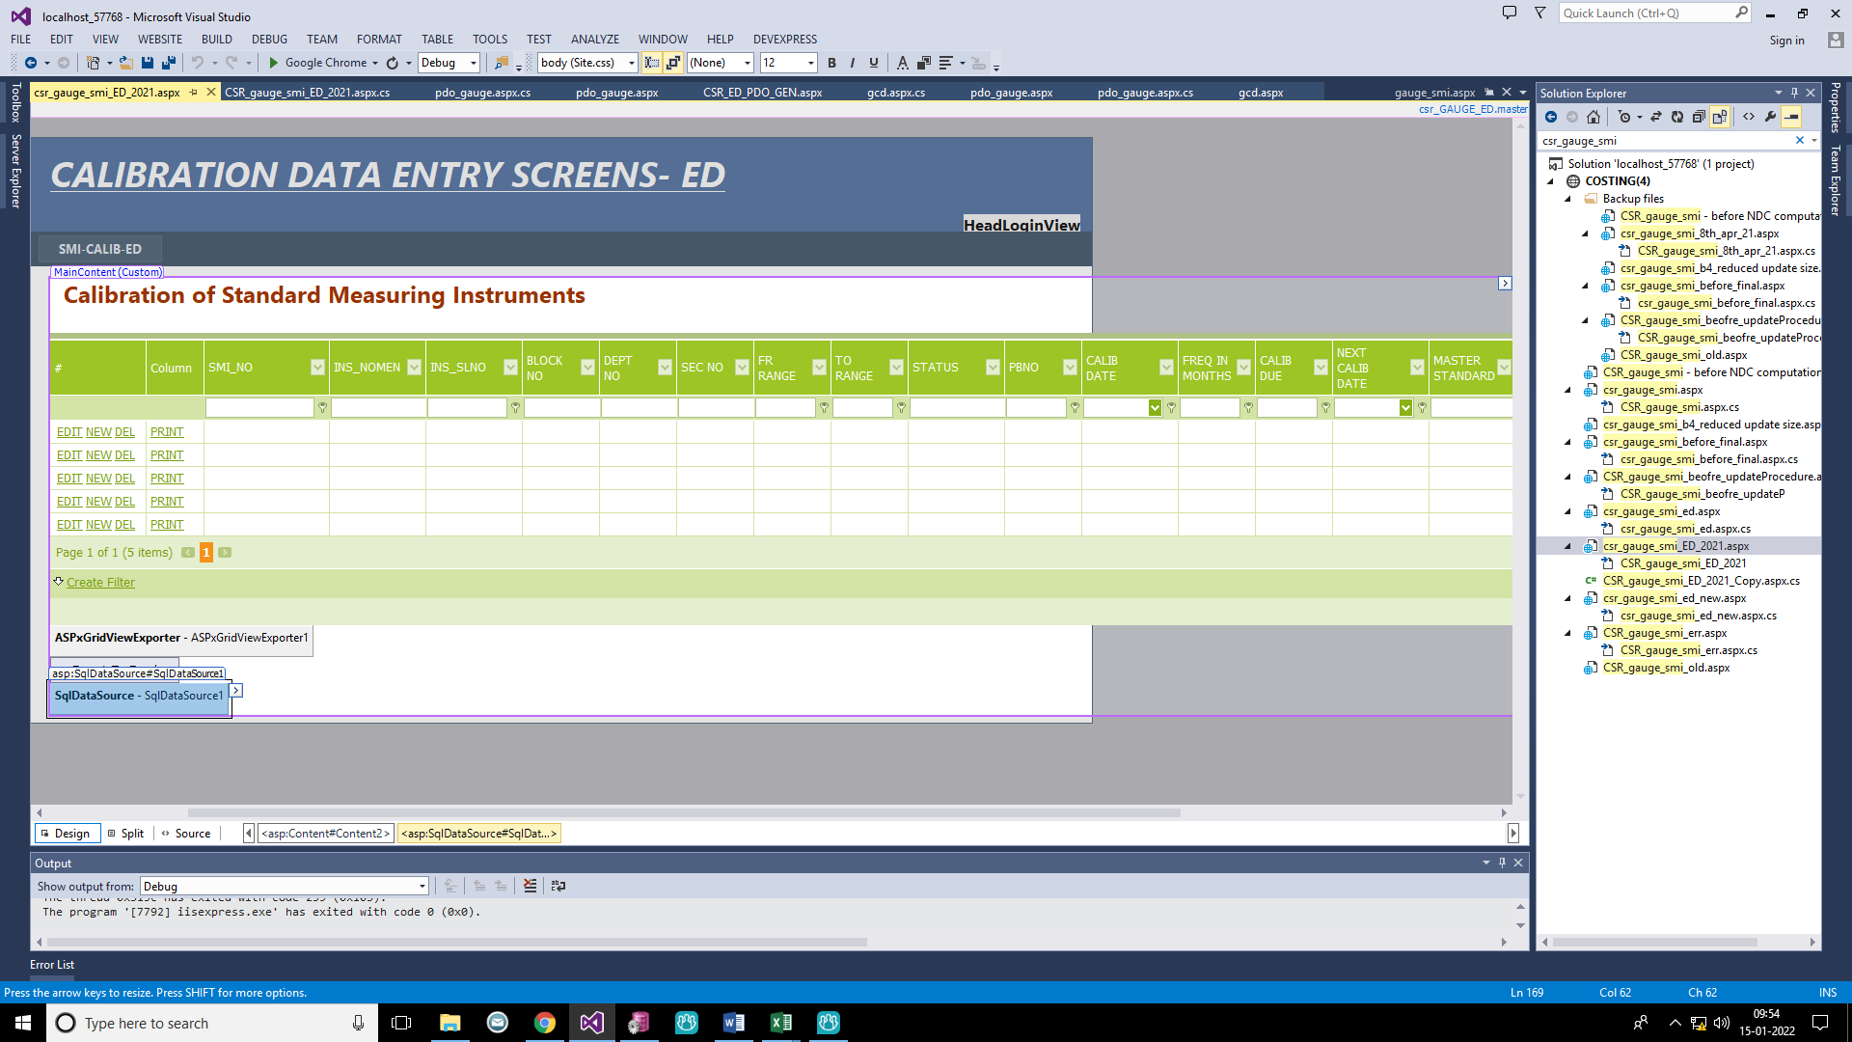

HOW TO RUN THIS PROGRAMME THROUGH GOOGLE CHROME

PROCEDURE: Step-1 :- 